

Predicting Municipal Financial Governance Risk as an Early Warning Indicator for Water Service Delivery: A Machine Learning Approach

N Hlumbene
Research Study submitted for the degree Honours in Computer Science & Information Technology at the North-West University (Vanderbijilpark Campus)

Supervisor: Prof Imelda Smit
Student number: 42452422

Abstract
The persistent failure of South African municipalities to deliver reliable water services remains a significant governance challenge despite the existence of legislative frameworks such as the Municipal Finance Management Act (2003) and oversight mechanisms administered by the Auditor-General of South Africa. Traditional audit-based accountability systems have proven insufficient at identifying municipalities at risk of service delivery failure before communities are materially affected, largely because they assess financial compliance retrospectively rather than predicting operational risk proactively. This study addresses a contextual gap in the literature by applying machine learning to predict next year municipal financial governance risk, as a proxy early warning indicator for water service delivery risk, using publicly available financial data.

A dataset of 3 375 records covering 292 municipalities across 14 financial years from 2012 to 2025 was constructed by merging four categories of municipal financial data from the Municipal Money portal, which aggregates verified records from the Auditor General of South Africa and the National Treasury. A municipality year was labelled high risk if irregular or unauthorised expenditure exceeded R10 million or fruitless and wasteful expenditure exceeded R1 million; after records with unknown labels were excluded, 2 617 records remained. Using only the previous year's financial data, with median imputation and missing value indicators, three supervised machine learning algorithms (Decision Tree, Logistic Regression and Random Forest) were trained on earlier years, tested on later years and compared with two simple baselines under a positivist research paradigm.

The Random Forest performed best of the three algorithms, with a ROC AUC of 0,82 and a balanced accuracy of 0,72 in a rolling backtest from 2019 to 2024. However, this was only slightly better than repeating each municipality's label from the previous year (balanced accuracy 0,71), and its overall accuracy (82,9%) was below that of classifying every municipality as high risk (85,2%). Earlier model versions that appeared to achieve accuracy above 99% were shown to suffer from data leakage. SHAP analysis showed that the previous year's unauthorised, irregular and fruitless and wasteful expenditure were the strongest predictors, indicating that financial governance risk is highly persistent.

The findings show that public financial records contain some early warning signal about future financial governance risk, but the models cannot be claimed to predict water service delivery outcomes accurately. The target is a financial governance proxy that was not validated against direct water service measures, and the data were sparse and strongly imbalanced. The study nonetheless contributes a leakage free evaluation approach and a realistic baseline for future data driven oversight of water service delivery in South African local government.

Table of Contents
Abstract 1
List of Tables 7
List of Figures 8
Abbreviations 9
CHAPTER 1: INTRODUCTION 10
1.1 Introduction 10
1.2 Concepts Central To Study 10
1.2.1 Operational Infrastructure Risk and Water Service Delivery 10
The Gap in Compliance Performance and Audit Outcomes 11
Binary Classification with Supervised Machine Learning 11
Handling Missing Data through Imputation 12
SHapley Additive exPlanations 12
1.3 Problem Statement 12
Justification for the Proposed Study 13
Research Aim and Objective(s) 13
Research Question(s) 14
1.4 Research Methodology and Design 14
Research Paradigm 15
Research Methodology 15
Machine Learning Life Cycle 16
Project scope 17
Project Limitations 18
Risk Mitigation Matrix 18
Software Resources and Development Platform 19
1.5 Ethical Considerations 19
Upholding Data Integrity and Usage 20
Protecting Personal Information 20
1.6 Study Overview 20
1.7 Conclusion 21
Chapter 2: Research methodology 22
2.1 Introduction 22
2.2 Research Paradigms 24
2.3 Research Methodology 25
2.4 Research Methods 27
2.4.1 Step 1: Data Collection 27
2.4.2 Step 2: Data Preprocessing 27
2.4.3 Step 3: Machine Learning Model Design 28
2.4.4 Step 4: Training and Evaluation 28
2.4.5 Step 5: Visualisation and Interpretability 28
2.6 Conclusion 28
CHAPTER 3: LITERATURE REVIEW 29
3.1 Introduction 29
3.2 Theoretical and Conceptual Background 30
3.2.1 Water Service Delivery as a Constitutional Mandate 30
3.2.2 The Compliance Performance Gap 30
3.2.3 Supervised Machine Learning, Imputation and Interpretability 31
3.2.4 Conceptual Framework 31
3.3 Review of Empirical Studies 31
3.3.1 Water Service Delivery Status and Challenges in South Africa 31
3.3.2 The Relationship Between Clean Audit Outcomes and Actual Service Delivery 33
3.3.3 Machine Learning as a Predictive Tool in Public Service Delivery 34
3.3.4 Data Preparation, Evaluation and Interpretability in Predictive Studies 35
3.3.5 Methodological Review 36
3.4 Synthesis of the Literature 37
3.5 Research Gap 38
3.6 How the Literature Guides the Study 38
3.7 Conclusion 39
Chapter 4: Empirical Study 41
4.1 Introduction 41
4.2 Experimentation Design 42
4.2.1 Prediction Model Architecture 42
4.2.2 Target Variable Operationalisation 42
4.2.3 Input Feature Matrix and Selection Reasoning 43
4.2.4 Algorithmic Implementations and Hyperparameter Tuning 43
4.3 Data Preparation and Refinement 44
4.3.1 Data Collection 44
4.3.2 Data Cleaning 45
4.4 Experimentation Conducted (ML Implementation) 48
4.4.1 Data Partitioning 48
4.4.2 Algorithm Training 49
4.4.3 Hyperparameter Tuning and Threshold Selection 49
4.5 Analysis of Results and Trustworthiness 49
4.5.1 Temporal Holdout Results 49
4.5.2 Rolling Backtest Results 52
4.5.3 Comparison with Earlier Model Versions 54
4.5.4 Trustworthiness 56
4.5.5 SHAP Interpretability 56
4.6 Findings 58
4.6.1 Model Performance 58
4.6.2 Risk Factors 59
4.6.3 Limitations of the Data 59
4.7 Conclusion 59
CHAPTER 5: CONCLUSION 60
5.1 Introduction 60
5.2 Overview of Research Journey and Achievement of Objectives 61
5.2.1 Evaluation of Research Questions 61
5.3 Research Contributions 63
References 66
Appendix A 68
Appendix B 69

List of Tables
Table 1 Risk Mitigation Matrix 18
Table 2 Temporal holdout results, test years 2021 to 2024 49
Table 3 Rolling backtest results, test years 2019 to 2024 52
Table 4 Random Forest performance across development rounds 55

List of Figures
Figure 1 ML Life Cycle 17
Figure 2 Study Overview 20
Figure 3 Chapter 2 Overview 23
Figure 4 ML Pipeline Flowchart 26
Figure 5 Raw municipal data as presented on Municipal Money website 45
Figure 6 Code for removing data leakage 47
Figure 7 Code for feature engineering 48
Figure 8 Temporal holdout performance of the models and baselines 50
Figure 9 Confusion matrices for the temporal holdout at a threshold of 0,5 51
Figure 10 ROC and precision recall curves for the temporal holdout 51
Figure 11 Observed and predicted share of high risk municipalities by test year 52
Figure 12 Trade off between recall for high risk cases and specificity for low risk cases in the rolling backtest 53
Figure 13 Random Forest confusion matrices for the rolling backtest, pooled over 2019 to 2024 54
Figure 14 Random Forest recall and specificity by rolling test year 54
Figure 15 Model scores across all development rounds 55
Figure 16 F1 score during training validation compared with the temporal holdout test 56
Figure 17 Mean absolute SHAP values for the final Random Forest 57
Figure 18 SHAP summary plot for the final Random Forest 58

Abbreviations
AGSA Audit General South Africa
ML Machine Learning
AI Artificial Intelligence
KNN K-Nearest Neighbours
SHAP SHapley Additive exPlanations
WSA Water Services Act
DWS Department of Water and Sanitation
ROC-AUC Receiver Operating Characteristic – Area Under the Curve

CHAPTER 1: INTRODUCTION

Introduction
The local government in South Africa plays an important role in ensuring that communities receive essential public service delivery such as water allocation, electricity and waste collection. To ensure and improve accountability and transparency in governance, frameworks such as the White Paper on Local Government and the Municipal Finance Management Act were introduced in 1998 and 2003, but despite this poor service delivery still persists (Phumlani et al., 2025:116). Conducting annual municipal audits was also introduced for the same purpose but audit outcomes often do not reflect the actual lived reality of many communities. Even in the Midvaal Local Municipality, which has achieved consecutive clean audits, the audit outcome on its own cannot be used as an effective determinant of good service delivery (Khasodi et al., 2023:347). This suggests that there are structural weaknesses in governance at play (S Mnguni, 2022:153).

This study proposes to address these gaps using supervised machine learning techniques. Because structured data on water service delivery are not available for every municipality and year, the study predicts next year municipal financial governance risk from publicly available financial data and treats this risk as a proxy early warning indicator for water service delivery. The primary aim is to evaluate how well machine learning models can anticipate this risk to support data driven decision making in the local government. The study therefore contributes to the underexplored research on the use of machine learning for early warning in South African local government and responds to the limitations of current audit based frameworks.

The remainder of this chapter will outline the Concepts Central To Study, Problem Statement, Research Methodology and Design, Ethical Considerations and the Study Overview.

Concepts Central To Study
This section briefly discusses the key concepts related to this study and an overview of related studies.

1.2.1 Operational Infrastructure Risk and Water Service Delivery
Water service delivery is a constitutional standard that has to be maintained by the local government, given that is forms part of the acting Water Service Authorities which are responsible for providing safe and continuous potable water for domestic purposes and institutions (Ishola et al., 2025:76). The municipalities are also obligated by the Water Services Act 108 of 1997 and Section 27(1)(b) of the Constitution of the Republic of South Africa to ensure water service delivery conforms to the national safety standards while simultaneously maintaining low health risk profiles during regulatory assessments conducted through frameworks such as Blue Drop Risk Rating (Ishola et al., 2025:81).

Water service delivery performance is primarily measured using three dimensions, namely quality compliance, service delivery continuity and quantity or access of water. Therefore operational risk factors increase when vulnerabilities such as losing high amounts of water from damaged pipes are the cause of persistent water interruptions, especially when they last for two days or more. This results in public protests when the well being of the affected communities being negatively impacted (Mamokhere, 2025:38; Nodipha et al., 2025:1372; Seema et al., 2025:4).

The Gap in Compliance Performance and Audit Outcomes
According to the Public Audit Act 25 of 2004 and the Municipal Finance Management Act 56 of 2003, organisations such as Auditor-General South Africa (AGSA) are supposed to publicly release annual regulatory assessments known as audit outcomes (S Mnguni, 2022:154; Sambo, 2019:201). Then there also exists a researched phenomenon in South Africa referred to as the “compliance gap” which refers to municipal audit results that do not match or forecast its actual service delivery performance (Khasodi et al., 2023:338). AGSA audit outcomes are considered an administrative compliance measure rather than a representation of operational quality indicators because they evaluate accounting regularity, supply chain compliance and financial reporting accuracy (Khasodi et al., 2023:338; S Mnguni, 2022:156). Therefore, this suggests that traditional auditing frameworks may be overlooking the underlying operational risk factors which allows municipalities obtain clean audits that are false while communities are negatively impacted by poor water service delivery (Khasodi et al., 2023:338).

Binary Classification with Supervised Machine Learning
Machine Learning (ML) is a subfield of Artificial Intelligence (AI) whereby computer algorithms are trained to learn mathematical predictive functions. During the training, a labelled historical dataset is used as input features for the algorithm. For this study, the supervised ML has the potential to change traditional administrative governance into proactive forecasting that can be used for better decision making (Obunga et al., 2025:732).

Handling Missing Data through Imputation
Imputation is a data preprocessing technique that fills in missing values so that incomplete records can be retained rather than deleted. This is important for this study because real world municipal datasets often contain missing values as a result of inconsistent record keeping (Ishola et al., 2025:80). Approaches range from simple median imputation to distance based methods such as K Nearest Neighbours (KNN) imputation (Hirko et al., 2026:18; Troyanskaya et al., 2001:520). This study uses median imputation combined with missing value indicators, which also allows the model to learn whether the fact that a municipality did not report a value is itself a warning sign.

SHapley Additive exPlanations
SHapley Additive exPlanations (SHAP) is a technique used to measure how each individual feature contributes to a model prediction. In the context of this study, SHAP analysis can convert difficult model outputs into comprehensible risk ranking that can be interpreted by non-technical people. This has the potential to reveal which financial indicators drive the predicted risk (Hirko et al., 2026:29).

Problem Statement
Section 27(1)(b) of the Constitution of the Republic of South Africa and the Water Services Act (WSA) 108 states that the South African local government is obligated by these laws to deliver safe and good quality water to all communities, while AGSA is one of the primary organisations responsible for enforcing financial accountability and regularity over all municipalities. Despite these frameworks being implemented, water service delivery outcomes in South Africa have been declining for many years. Communities are constantly experiencing recurrent water supply interruptions, decaying infrastructure, non-revenue water loss and an increase in public protests. Most of these effects stem from the problem of compliance and performance gap between what audit outcomes reveal and the actual lived lives of community members affected (Mofokeng et al., 2025:6). Therefore, it is possible for a municipality to present good audit outcomes while experiencing underlying risk factors such as neglected asset maintenance and load shedding with electricity.

This suggests that traditional frameworks lack the ability to proactively support decision-making in the local government in a manner that synthesises financial compliance indicators with operational risk indicators. Therefore, the application of ML algorithms has the potential to expose the underlying risk factors that contribute to poor water service delivery. Thus far they have been successfully applied in fields such as healthcare and environmental engineering while their application to forecast service delivery in the local government remains underexplored (Igbokwe & Nwamekwe, 2025:14). Furthermore, this might decrease the number of vulnerable communities that have been persistently enduring poor water service deliveries.

Justification for the Proposed Study
Combining the traditional municipal auditing systems with more proactive and early-warning forecasting might enable local government decision makers and the Department of Water and Sanitation (DWS) are able to identify municipalities that are at high risk before water service delivery collapses. This will allow decision-makers to plan accordingly for targeted resource allocation and prevent unnecessary maintenance that could result from poor service delivery occurrences.

This study also proposes to bridge the gap between public sector management and computer science by modelling that the publicly available municipal datasets can be merged using techniques such as imputation and binary classification to create a predictive model, while SHAP analysis can be used for converting ML outputs into actionable governance insights for users (Igbokwe & Nwamekwe, 2025:15).

Research Aim and Objective(s)
This study’s aim is to compare three supervised ML algorithms and evaluate how well they predict next year municipal financial governance risk, as a proxy early warning indicator for water service delivery, using publicly available municipal financial data.

Theoretical Objectives:
- T-OBJ1: Analyse existing literature on municipal water service delivery problems, the constitutional responsibility for water supply and the effects poor water service delivery outcomes have on the communities affected.
- T-OBJ2: Review the documented compliance gap between audit results and actual service delivery performance.

Empirical Objectives:
- E-OBJ1: Conduct data collection, cleaning and preprocessing on municipal datasets using median imputation with missing value indicators and z-score standardisation.
- E-OBJ2: Select three supervised ML algorithms to train and tune, training them on earlier years and testing them on later years.
- E-OBJ3: Compare the three selected supervised ML algorithms against each other and against simple baselines based on performance.
- E-OBJ4: Identify the financial indicators that contribute most to predicted financial governance risk by applying SHAP analysis and evaluate whether the predictive insights can be used to improve governance decision-making.

Research Question(s)
This study’s main research question is:

How well can supervised machine learning algorithms predict next year municipal financial governance risk from publicly available financial data, and what does this suggest about early warning of water service delivery risk?

Theoretical research questions:
- TRQ1: What does the literature reveal about municipal water service delivery problems, the constitutional responsibility for water supply and the effects of poor water service delivery on communities?
- TRQ2: What does the literature reveal about the gap between municipal audit outcomes and actual water service delivery performance?
Empirical research questions:
- RQ1: Which publicly available municipal data source is suitable for this study, and how can its missing records be handled through imputation?
- RQ2: How do the three selected supervised ML algorithms compare with each other and with simple baselines in predicting financial governance risk?
- RQ3: Which financial indicators contribute the most to predicted financial governance risk according to SHAP analysis results?
- RQ4: How can the insights from the predictive modelling contribute to the local government’s decision-making?

Research Methodology and Design
This section discusses the selected research for this study and justifies it, research methodology, data processing pipeline and system life cycle applied to the predictive ML model.

Research Paradigm
A research paradigm is a framework that can be used by the researcher as a guide to interpret reality and also generate knowledge. In considering the appropriate research paradigm for this study, it was important to acknowledge the range of paradigms that guide information systems and applied computer science research. The researcher had the option to select between four paradigms, namely: Positivism, Critical Social Theory, Critical Realism and Interpretivism (Goede).

Positivism was chosen as the guiding paradigm for this study because its focus is on designing machine learning models to predict municipal financial governance risk as an early warning indicator for water service delivery. This is a quantitative task that requires structured data, statistical testing and measurable results. Positivism supports replicable and generalisable findings which fits well with the use of publicly available municipal financial datasets. Machine learning also relies on measurable variables and statistical inference, making positivism the most compatible approach. Other paradigms like interpretivism, critical social theory and critical realism provide useful insights into governance and social dynamics but they don’t align directly with the technical goal of predictive modelling.

Research Methodology
This study follows a quantitative empirical research methodology to align with the selected Positivism paradigm. This methodology uses secondary numerical data that is structured and collected from https://municipaldata.treasury.gov.za/ which is a verified government repository for municipal audit datasets. This approach ensures that scientific objectivity is enforced by ensuring the resulting predictive model is grounded only based on computed mathematics and not the researcher’s opinion.

For the task of predicting whether a municipality will be at high financial governance risk, three supervised ML algorithms will be implemented and compared. They are Decision Trees, Logistic Regression and Random Forest and were selected based on their relevance to classification tasks, their use in comparable predictive studies in African and developing-world contexts and the potential they have to be interpretable to non-technical users in municipal governance settings. The Decision Trees algorithm is a transparent prediction mechanism, it presents the model's logic as a series of conditional rules that can be visualised and explained with no advanced technical knowledge.

This might be an advantage in the local government where it is important for the users to understand and interpret not only what the model predicts, but why. The Logistic Regression algorithm is a statistically grounded baseline model that works well with binary classification tasks. It offers coefficient outputs that are interpretable and can indicate the direction and strength of each relationship a predictor has with the outcome variable. A Random Forest algorithm is an extension of the Decision Trees algorithm. It ensembles trees trained on a random subset of the data, which may produce more accurate and robust predictions than a single decision tree, particularly in a dataset such as municipal data with complex interactions between features (Hirko et al., 2026:18; Sylvain et al., 2025:2).

The classification task has a binary target variable that indicates whether a municipality will be at high financial governance risk in the following year. The study initially considered defining poor performance through the frequency of water interruptions, household access to water or a composite index, but these indicators are not available in a structured form for every municipality and year. The target was therefore defined through thresholds for irregular, unauthorised and fruitless and wasteful expenditure, as explained in Chapter 4, Section 4.2.2, and is used as a proxy for water service delivery risk.

Machine Learning Life Cycle
For the empirical study a step by step ML data life cycle is followed:
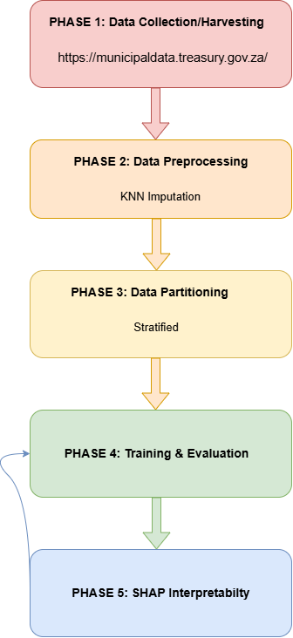
Figure 1 ML Life Cycle

Project scope
- The geographic and administrative boundary of the project includes 292 municipalities that range from metropolitan, local and district under the local government sphere across all nine South African provinces.
- The dataset covers financial years from 2012 to 2025, with outcome years from 2013 to 2024 used for modelling.
- The technical scope includes binary classification of next year municipal financial governance risk, as an early warning indicator for water service delivery, using Decision Trees, Logistic Regression and Random Forest algorithms with SHAP analysis applied for interpretation.

Project Limitations
- The model is dependent on secondary administrative data that is only published annually on regulatory reporting cycles rather than data that can be accessed on real time demand.
- To preserve longitudinal consistency, dataset aggregation was necessary due to municipal mergers and boundary realignments during the study period.
- The target variable is a financial governance proxy defined through expenditure thresholds and has not been validated against direct water service measures.
- Several financial variables are missing for most municipalities, and only 213 to 234 municipalities could be used in each year.

Risk Mitigation Matrix
Potential project risks were identified with mitigation strategies to maintain technical and methodological uncertainties:

Table 1 Risk Mitigation Matrix
Risk Description | Severity | Likelihood | Impact Area | Mitigation Strategy
Missing values in the municipal dataset due to unstable administration and record keeping. | High | High | Data Quality | Exclude records with unknown outcome labels and apply median imputation with missing value indicators to the remaining features
One outcome class being under represented compared to the other | High | Medium | Model Bias | Use class weighting and tuned classification thresholds, and evaluate with balanced accuracy, specificity and ROC AUC against simple baselines.
Algorithmic Overfitting | Medium | High | Generalisation | Set minimum leaf samples and constrain tree depth and use year ordered cross validation.
Falling behind | Medium | Medium | Project Completion | Maintain a schedule that is milestone driven and request supervisor feedback regularly.

Software Resources and Development Platform
The development of the prediction model was an open source data science software technical stack chosen because it eliminates software licensing costs. It also provides for seamless integration for completing the ML life cycle (Mofokeng et al., 2025:3).

- The programming language that was selected is Python because of its sophisticated ecosystem of machine learning frameworks it offers and libraries for data manipulation. It also offers a lot of support in terms of model interpretation tools.
- Jupyter Notebook was selected for the model because of its interactive and user friendly coding environment and also its provision for reproducible generation of documentation.
- Microsoft Excel was used for data analysis prior to the ML life cycle phase of the project.
- The main libraries that were used include pandas and numpy for data ingestion, feature encoding and data merging, scikit-learn for data partitioning, median imputation, cross validation and implementing the supervised ML algorithms and matplotlib for plotting ROC-AUC curves, SHAP charts and confusion matrices.

Ethical Considerations
Although this study relies on publicly available data rather than data collected directly from individuals, several ethical considerations remain relevant. The study will ensure that all data used has been sourced from legitimate and publicly accessible platforms and that no personally identifiable information is incorporated into the analysis. The study acknowledges that predictive models carry inherent risks of misclassification and that the outputs of the model should be communicated as probabilistic indicators rather than definitive assessments of municipal performance. The research will be conducted in compliance with the ethical guidelines of North-West University and the broader principles of responsible research practice. The repository for the dataset used is available at: https://municipaldata.treasury.gov.za/. A signed ethics form is also included in this document as an appendix.

Upholding Data Integrity and Usage
- During the completion of this study, none of the raw data will be fabricated, falsified or altered to enforce false results. Any preprocessing techniques such as median imputation and z-score standardisation will be executed in coding pipelines that are documented and mathematically objective (Ishola et al., 2025:80).
- NWU Harvard citation formats were used to acknowledge all open source software libraries and data sources.

Protecting Personal Information
South Africa has a law that protects data and how its regulated and maintained. This law is called Protection of Personal Information Act (POPIA Act). The data used in this study and for modelling does not contain any individual citizen records or any Personally Identifiable Information (PII). The dataset includes municipal institutional records that are publicly available in online repositories. This study also has no privacy infringement because it poses zero risks of individual privacy or identity violations. Therefore, no household record, individual citizen or local government employee data was collected, processed or stored for this study (Ngcobo, 2025:77).

Study Overview

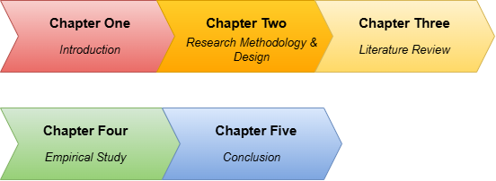
Figure 2 Study Overview

Conclusion
In conclusion, this chapter discussed and introduced the theoretical and methodological concepts that cover the concepts related to using supervised machine learning algorithms as a predictive method for municipal financial governance risk, as an early warning indicator for water service delivery in the local government. It started by discussing the local government’s important role in continuously providing citizens with safe and good quality water. Then it highlighted how poor water service delivery is still persistent in most communities despite the existence of frameworks implemented to promote transparency and accountability in governance.

Furthermore, the chapter discussed the identified compliance gap that exists between the government’s audit results and the actual service delivery communities receive, then to address this gap, the research aim, questions and objectives were discussed. To elaborate on the study’s research methodology, the selected paradigm which is Positivism was discussed and justified with the machine learning life cycle introduced to aid in justifying the chosen research methods. Lastly, the project plan was discussed along with the ethical considerations for the research and an overview for this study. Therefore, this study continues to Chapter 2 where the research methodology will be discussed in depth with the selected Positivism paradigm, research methods and the study’s empirical framework.

Chapter 2: Research methodology

2.1 Introduction
In this chapter the empirical objectives of this study are addressed by outlining the methodology required to implement a machine learning model that forecasts next year municipal financial governance risk as an early warning indicator for water service delivery in the local government. The model should identify the financial indicators associated with high risk and flag municipalities before problems escalate. The design incorporates publicly available municipal financial data and follows the positivist paradigm, which aligns with the study’s main objective of exposing local government decision makers to data driven insights. The chapter also addresses the objectives to collect and preprocess municipal financial datasets, to identify and evaluate the indicators that contribute most to predicted risk and to evaluate how the predictive insights can enhance efficiency, accountability and decision making in the local government.

A detailed description of the methodology will also be provided to discuss the approaches chosen to forecast municipal financial governance risk in the local government. This will set forth the theoretical foundations for the study’s quantitative nature and outline the procedure necessary to preserve objectivity during the generation of forecasts using Machine Learning. Furthermore this section will discuss what is important to ensure the collected municipal data is valid and reliable, by addressing the critical aspects of rigour and trustworthiness.

The following sections of the chapter will provide a logical roadmap of the research methodology process and discuss other paradigms applicable to computer science studies, followed by a thorough discussion of the research paradigm chosen for this study. Finally, the conclusion will include a summary of what was discussed in the chapter and also outline future directions for the next chapter.

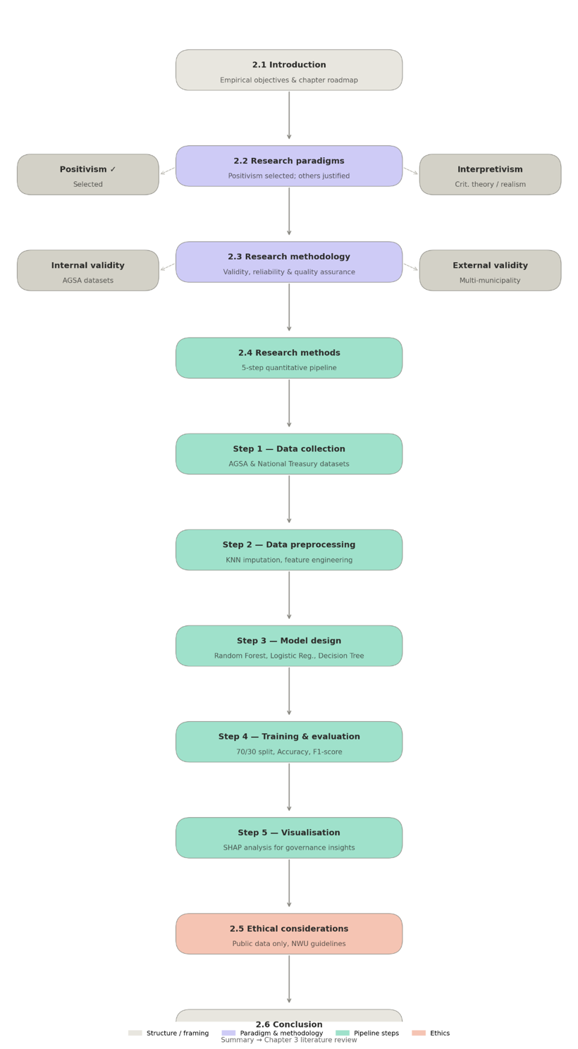
Figure 3 Chapter 2 Overview

2.2 Research Paradigms
A research paradigm can be described as an approach to research that can be used as guidance on how to interpret reality. Each paradigm is primarily defined by three fundamental questions: the nature of reality, the nature of knowledge and how it is acquired and the processes used to acquire knowledge. For computer science related studies there is 4 paradigms that can be applied: Positivism, Interpretivism, Critical Social Theory and Critical Realism.

- Positivism’s foundation relies on the idea that there only exists one objective reality apart from our human perception. Using this paradigm the researcher will measure, test and attempt to identify patterns using empirical data that fits their study’s context. The researcher also needs to maintain an objective and detached role throughout the entire process to ensure the methodology remains repeatable, systematic and value-neutral.
- Interpretivism holds that human meanings and interactions shape our reality which makes it socially constructed. This paradigm’s aim to evaluate and lived experiences through tools such as surveys where the researcher is able to collect qualitative data to understand the “how” and “why” of a phenomenon or event.
- Critical Social Theory is a paradigm that focuses on social change and emancipation by identifying and challenging oppressive social structures. With this paradigm the researcher does not have a detached role throughout the process, instead they will act as an agent of change in order to fulfil this paradigm’s main objective.
- Critical Realism offers a middle ground where reality gets divided into three domains. The first one is the real domain which refers to the underlying structures. The second is the actual domain which refers to the actual occurring events. Finally the third is the empirical domain which refers to what we are able to see and measure. This way this paradigm acknowledges that we live in an objective reality but it is also epistemologically cautious to recognise that sometimes our understanding of this world can be faulty or influenced by other humans and experiences.

The positivism paradigm was selected for this study because it has the most appropriate framework that aligns with the study’s main objectives and goals to measure, test and identify patterns in municipal data to design a model that can predict municipal financial governance risk. Therefore, this makes this a quantitative task where there will be a formulation of hypotheses to be tested against structural and numerical data.

This study will also need publicly available datasets which is consistent with the standards of the positivism paradigm. The aim is to ensure the data collection and analysis processes are able to be reproduced and analysed by other researchers to maintain a high standard of rigour. This is the reason why alternative paradigms were deemed not suitable for this study. Interpretivism was not selected because it lacks the technical predictive modelling standard required to use municipal datasets to predict financial governance risk. Critical Social Theory was not chosen because it leans more towards active social intervention while this study leans more towards operationalising a quantitative model.

While Critical Realism would also benefit the part of the study that mentions the local government as a complex social system, it was not chosen because it does not satisfy the main objective of this study which is to design a predictive model. This paradigm also does not align with the study’s quantitative empirical objectives because it leans more towards an abductive approach.

2.3 Research Methodology
This section will outline the quantitative methods that will be adopted in order to fulfil the study’s main objectives. These methods will be applied in a valid manner that aligns with the Positivism paradigm. These methods will be necessary to ensure that the Machine Learning model designed with the utilisation of municipal data is rigorous and adheres to the proper scientific standards of Artificial Intelligence and Machine Learning. The positivism paradigm will also establish the study’s trustworthiness to ensure validity and reliability.

This study will address two primary dimensions of validity which is Internal Validity and External Validity. These dimensions are included to be addressed by the study because they will outline the extent to which the research accurately measures the quantitative data it intends to utilise. Therefore ensuring that the findings truly represent and align with the study, and also answer the study’s research questions.

With internal validity it is guaranteed that any risk factors identified by the proposed model such as municipal audit outcomes and financial indicators, are genuinely associated with the predicted financial governance risk. To maintain high internal validity, only structured and verified datasets from organisations such as the Auditor-General South Africa (AGSA) will be used. This way the risk of measurement errors and omitted variable bias is decreased to preserve the model’s accuracy during prediction.

External validity aligns with the approach of the positivism paradigm because its goal is to ensure the findings are generalisable across different municipal contexts in the South African local government. To ensure external validity the study will utilise datasets covering different metropolitan and local municipalities so the developed model’s predictive rules can be applied beyond specific training data.

For reliability, the consistency and stability of the research tools and findings is important. With this study’s context of Machine Learning modelling this will ensure that if the research were to be replicated using the same dataset and algorithms, the same results are produced. Therefore, this research’s approach will adhere to a systematic and replicable workflow that will include steps for data cleaning, feature selection and algorithm configuration. The usage of standard Machine Learning libraries and statistical software will also ensure the research output is not dependent on subjective researcher interpretation but mathematical computation that can be repeated.

Finally, for quality assurance the model’s performance will be analysed as the last stage of methodological rigour. Accuracy, precision, recall, specificity, balanced accuracy, F1 score and ROC AUC will be used to verify the model’s ability to differentiate between high and low financial governance risk, and the models will be compared with simple baselines. To test the models on unseen data, they will be trained on earlier years and tested on later years, which avoids overfitting to the training data and reflects how the model would be used in practice.

For the context of this study the research design is structured as a predictive modelling pipeline. It ensures a systematic and replicable flow from raw municipal data to actionable insights that can be used for decision-making in governance.

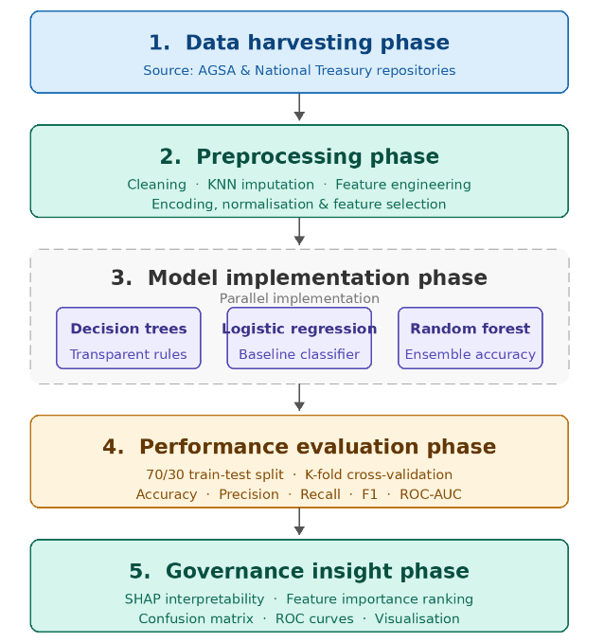
Figure 4 ML Pipeline Flowchart

This research design's structured and linear form supports positivism's demand for objectivity. The design guarantees that the researcher stays an impartial observer of the data by predetermining the variables, algorithms and evaluation measures. Because every stage of this design is replicable, the fundamental scientific condition of reliability might be accomplished by another researcher using the same National Treasury datasets and algorithmic parameters

2.4 Research Methods
This section will outline the specific tools and methods to be used to collect and analyse the data that will answer the study’s research questions. A quantitative research approach will also be adopted to ensure alignment with the positivism paradigm. This paradigm was justified as appropriate because it will allow the use numerical data to test hypotheses and identify the connection between the municipal data and financial governance risk.

The application and selection of quantitative methods for this study is dictated by the study’s objective to design a predictive Machine Learning model. The quantitative methods that are suited for this task involve the measuring of relationships and predictions outcomes based on large and structured datasets. While qualitative methods may have the potential to provide contextual depth for the study, they lack the statistical generalisability and computational scalability required to design an appropriate robust, data-driven forecasting model.

To ensure the study is replicable and rigorous, the research process will consist of a step-by-step workflow:

2.4.1 Step 1: Data Collection
Secondary quantitative data will be collected from sources that are publicly available such as the National Treasury and Auditor-General South Africa (AGSA). These sources offer the public and South African municipalities verified audit results and financial indicators.

2.4.2 Step 2: Data Preprocessing
The raw collected data will undergo a cleaning process to ensure data anomalies such as duplicates and missing values are addressed. Depending on the amount and extent of the missing data, techniques such as median imputation, with indicators that record where values were missing, will be applied. Then feature engineering will be used to derive the variables that captured long term performance trends instead of variables that captured single-year performances.

2.4.3 Step 3: Machine Learning Model Design
Three supervised machine learning algorithms will be put into practice and contrasted. They are the Random Forest, Logistic Regression and Decision Trees algorithm and were chosen due to their shown effectiveness in classification tasks and their potential for interpretability in governance contexts.

2.4.4 Step 4: Training and Evaluation
To verify the models’ predictive ability on unseen data, they will be trained on earlier financial years and tested on later years rather than on a random split, so that no information from the future is used. Performance will be assessed using accuracy, balanced accuracy, precision, recall, specificity, F1 score and ROC AUC and compared with simple baselines, so that the models are fairly evaluated despite class imbalance in municipal performance.

2.4.5 Step 5: Visualisation and Interpretability
SHAP (SHapley Additive exPlanations) analysis will be used to convert technical data into useful governance insights. This technique determines whether particular risk factors such as poor financial management or deteriorating infrastructure have the most effects on the model's forecasts or not.

2.6 Conclusion
In conclusion, the systematic methodological framework required to handle the study's empirical objectives has been outlined in this chapter. The research ensures that evaluation of municipal financial governance risk is objective, empirical and replicable through the application of a positivist paradigm. In order to guarantee the final Machine Learning (ML) model's rigour and trustworthiness, the chapter defined the technical standards for validity and reliability. A clear roadmap for the data-driven predictive pipeline, from the initial data collecting at the Auditor-General of South Africa (AGSA) to the comparative application of supervised learning algorithms, was also provided by the thorough description of research methodology and design.

Now that the study's technical design and methodological structure have been defined, the following chapter places this research in the context of a larger scholarly discussion. A thorough literature review is presented in Chapter 3, which examines the core concepts guiding the study, points out existing gaps in the area of municipal governance research and evaluates the state of machine learning applications in local government.

CHAPTER 3: LITERATURE REVIEW

3.1 Introduction
The persistent failure of South African municipalities to provide reliable water services, despite an extensive legislative and oversight framework, is the problem that underpins this study. Frameworks such as the White Paper on Local Government of 1998 and the Municipal Finance Management Act (MFMA) 56 of 2003 were introduced to strengthen accountability and transparency in local government, yet poor service delivery persists in many local and metropolitan municipalities (Phumlani et al., 2025:116). At the same time, machine learning (ML) has emerged as a means of shifting public governance from reactive reporting towards proactive forecasting (Obunga et al., 2025:732).
This literature review examines existing scholarship on municipal water service delivery, audit based accountability and the application of machine learning in public services, with the aim of identifying key themes, debates and methodological gaps. In doing so, it addresses the two theoretical objectives of the study, namely to analyse the literature on municipal water service delivery problems, the constitutional responsibility for water supply and the effects of poor service on communities, and to review the documented gap between audit results and actual service delivery performance.
The scope of the review is limited to two bodies of literature. The first is South African research on municipal governance, audit outcomes and water service delivery. The second is research on machine learning applications in resource constrained public sectors, mainly healthcare, water resource management and municipal solid waste management, together with methodological studies on missing data, model evaluation and interpretability. Literature on other municipal services, such as electricity and housing, is considered only where it sheds light on water service delivery, and the technical detail of individual algorithms is reserved for Chapter 4.
The review is organised thematically. Section 3.2 presents the theoretical and conceptual background of the study. Section 3.3 reviews the empirical literature under four themes: the status and challenges of water service delivery in South Africa, the relationship between clean audit outcomes and actual service delivery, machine learning as a predictive tool in public service delivery, and data preparation, evaluation and interpretability in predictive studies, followed by a comparison of the methods used across these studies. Section 3.4 synthesises the literature, Section 3.5 states the research gap, Section 3.6 explains how the literature guides the design of this study and Section 3.7 concludes the chapter.

3.2 Theoretical and Conceptual Background
Three concepts frame this study: the constitutional mandate for water service delivery, the compliance performance gap in municipal auditing and supervised machine learning supported by data imputation and interpretability techniques. This section introduces each concept and then shows how they combine into the conceptual framework that guides the study.

3.2.1 Water Service Delivery as a Constitutional Mandate
Water service delivery is a constitutional standard that municipalities, acting as Water Services Authorities, must uphold by providing safe and continuous potable water for domestic and institutional use (Ishola et al., 2025:76). Section 27(1)(b) of the Constitution of the Republic of South Africa and the Water Services Act 108 of 1997 further require that the water supplied conforms to national safety standards, with compliance assessed through regulatory frameworks such as the Blue Drop Risk Rating (Ishola et al., 2025:81). In the literature, service performance is commonly understood along three dimensions, namely water quality compliance, continuity of supply and quantity or access, and interruptions lasting two days or more are associated with community protest (Mamokhere, 2025:38; Nodipha et al., 2025:1372; Seema et al., 2025:4). These three dimensions define what poor water service delivery means. Because structured data on them are not available for every municipality and year, this study uses financial governance risk as a proxy early warning indicator for water service delivery.

3.2.2 The Compliance Performance Gap
The Public Audit Act 25 of 2004 and the MFMA require the Auditor General of South Africa (AGSA) to publish annual audit outcomes for municipalities (S Mnguni, 2022:154; Sambo, 2019:201). These outcomes assess accounting regularity, supply chain compliance and the accuracy of financial reporting, which makes them a measure of administrative compliance rather than of operational quality (Khasodi et al., 2023:338; S Mnguni, 2022:156). The term compliance gap describes the documented mismatch between a municipality's audit results and its actual service delivery performance (Khasodi et al., 2023:338). This concept is central to the study because it explains how several municipalities obtain clean audits notwithstanding inadequate service delivery performance (Khasodi et al., 2023:338), and it motivates the search for indicators that look beyond the audit opinion.

3.2.3 Supervised Machine Learning, Imputation and Interpretability
Machine learning is a subfield of artificial intelligence (AI) in which algorithms learn predictive functions from labelled historical data, and in governance settings supervised learning has the potential to turn traditional administrative oversight into proactive forecasting (Obunga et al., 2025:732). Binary classification, in which each case is assigned to one of two classes, suits the question of whether or not a municipality is at high financial governance risk. Two supporting techniques are relevant to this study. Imputation fills missing values so that incomplete records can be retained, using approaches that range from simple median replacement to K Nearest Neighbours (KNN) imputation, which draws on the most similar records (Hirko et al., 2026:18). This matters because municipal records are frequently incomplete as a result of inconsistent record keeping (Ishola et al., 2025:80). SHapley Additive exPlanations (SHAP) assigns each feature an importance value for a particular prediction (Lundberg & Lee, 2017:4765) and can translate complex model outputs into risk rankings that nontechnical users are able to interpret (Hirko et al., 2026:29).

3.2.4 Conceptual Framework
Taken together, these concepts form the conceptual framework of the study. Publicly available municipal financial data serve as the inputs; imputation and feature engineering prepare these inputs; supervised classifiers predict whether a municipality will be at high financial governance risk in the following year, as an early warning indicator for water service delivery; and SHAP translates the predictions into risk factors that decision makers can act upon. The compliance gap provides the rationale for this framework, because it suggests that municipal financial data may contain warning signals that the audit opinion alone does not reveal. The empirical literature reviewed in the next section tests the assumptions that underlie each part of this framework.

3.3 Review of Empirical Studies
The empirical literature is reviewed thematically. The first theme establishes the nature and causes of the water service delivery problem, the second examines why existing audit based monitoring fails to detect it, the third considers whether machine learning offers a credible means of anticipating it and the fourth examines the methodological choices that determine whether such predictions can be trusted. A comparison of the methods used across these studies concludes the section.

3.3.1 Water Service Delivery Status and Challenges in South Africa
Although access to water has improved nationally, the literature shows that this progress is unevenly distributed between and within municipalities. Ishola et al. (2025:84) report that access to improved water sources rose from 85,1% in 2011 to 88,5% in 2022, but they also show that while metropolitan municipalities such as the City of Cape Town (99,8%) and Ekurhuleni (99,3%) maintain near universal access, Buffalo City and eThekwini record high rates of service interruption. The same study points to a dual service experience in which 79% of urban residents are satisfied with the quality of their water, compared with only 64% of rural residents, many of whom still depend on rivers and wells. Mamokhere (2025:36) links such failures to growing unrest, noting that 38% of riots in early 2024 were associated with water or electricity problems. Read together, these studies suggest that national averages conceal serious risk at municipal level, which supports the decision in this study to assess risk for individual municipalities rather than for provinces or the country as a whole.
Deteriorating infrastructure is consistently identified as a primary cause of service failure. Seema et al. (2025:5) found that 80% of the reticulation network in the Modimolle Mookgophong Local Municipality (MMLM) consists of ageing asbestos pipes, which results in frequent winter bursts and substantial water losses. Nodipha et al. (2025:1375), in their study of the Mnquma Local Municipality, add that external pressures such as load shedding, together with the theft of cables and water pumps and vandalism, further disrupt the treatment and distribution of water. Whereas Seema et al. (2025:5) emphasise the physical condition of assets, Nodipha et al. (2025:1375) draw attention to operational shocks that lie partly beyond municipal control, which implies that even well maintained systems remain vulnerable. Although these findings are instructive, they rely on direct observation of infrastructure, whereas publicly available municipal datasets do not record pipe condition or interruption events. Infrastructure risk must therefore be approximated in this study through financial indicators such as repairs and maintenance expenditure.
Beyond physical infrastructure, the literature agrees that weak governance and financial mismanagement underlie many service failures. Mamokhere (2025:31) attributes current service delivery problems to limited institutional capacity, political and administrative interference and administrative inefficiency. In MMLM, for example, the Water Services Authority operates at only about 70% of its capacity because of a serious shortage of certified process controllers and skilled staff (Seema et al., 2025). Ishola et al. (2025:91) similarly observe that even where funds are available, institutional inefficiency and financial mismanagement lead to a failure to maintain existing infrastructure, producing a cycle of reactive repairs rather than preventative maintenance. While Mamokhere (2025:31) frames the problem mainly in terms of institutional capacity, Ishola et al. (2025:91) place greater weight on how available funds are managed, but both locate the root cause in governance rather than in a simple shortage of resources. This convergence is significant for the present study, because it suggests that financial governance indicators, which municipalities are required to report publicly, may carry information about future service failure.
If financial mismanagement contributes to service failure in this way, it is reasonable to ask why the audit system, which is designed to detect such mismanagement, has not served as an effective early warning mechanism. This question leads to the second theme.

3.3.2 The Relationship Between Clean Audit Outcomes and Actual Service Delivery
Whether financial compliance predicts operational performance is a recurring question in South African municipal governance research. A clean audit outcome, a concept specific to the South African municipal context, indicates that a municipality's financial statements are free of material misstatement, that it has complied with applicable legislation and that it has reported accurately against its predetermined performance objectives. Legislative frameworks such as the MFMA assume that sound financial management is the foundation of effective service delivery. Sambo (2019:5) challenges this assumption, arguing that an unqualified audit opinion does not necessarily mean that public services are delivered effectively or efficiently. The Western Cape illustrates the point: although it has historically recorded the highest proportion of clean audits, at about 70%, service delivery protests linked to perceived shortages of housing and infrastructure remain common (Sambo, 2019:5). This implies that audit results are produced after the fact and may miss the underlying causes of poor service delivery, such as deteriorating infrastructure or weak leadership.
Craig (2017:3) reaches a similar conclusion through empirical analysis, finding at most a weak correlation between clean audits and service delivery. According to Craig (2017:3), a municipality's ability to deliver services is shaped less by its audit status than by its operational context, which includes regional wealth, population density and the availability of infrastructure. Craig (2017:3) further warns that the audit regime may create perverse incentives, because municipal departments may set modest performance targets rather than ambitious stretch targets in order to avoid adverse audit findings, effectively placing a clean audit ahead of developmental goals. Both Sambo (2019:5) and Craig (2017:3) therefore suggest that municipalities may achieve compliance by focusing on administrative tick box activities rather than meaningful service delivery.
Khasodi et al. (2023:347) reach a similar conclusion in a case study of the Midvaal Local Municipality, one of the few South African municipalities with consecutive clean audits. They find that even Midvaal's clean audit outcomes cannot be used as an effective determinant of good service delivery, because a clean audit does not necessarily translate into citizen satisfaction with service provision. However, Khasodi et al. (2023:347) also show that Midvaal's internal controls, including ethical leadership, consequence management, good revenue and financial management and accountability, place the municipality in a position to provide services and, in turn, produce its clean audit outcomes. Whereas Craig (2017:3) explains service delivery mainly through operational context, Khasodi et al. (2023:347) point to the management practices that sit behind the audit opinion. For this study, this distinction is important, because it suggests that the financial management behaviour reflected in municipal data, rather than the audit opinion itself, is where useful warning signals are most likely to be found.
S Mnguni (2022:157) adds a further dimension by identifying a regressive trend in which fewer municipalities obtain clean audits, owing to persistent irregular expenditure and noncompliance with supply chain management requirements. This trend places local government in a precarious financial position and widens the distance between the reports of the AGSA and the lived reality of communities. For this study, the observation is important because irregular expenditure is one of the few indicators that is both reported publicly for every municipality and directly connected to the quality of governance. Its behaviour over several years may therefore act as an early warning signal rather than merely as an audit finding.
The literature thus establishes that audit outcomes are retrospective and offer, at best, a partial view of service delivery. If the information needed to anticipate failure exists within municipal data but is not captured by the audit opinion, analytical methods that can detect complex patterns in such data become relevant. This leads to the third theme.

3.3.3 Machine Learning as a Predictive Tool in Public Service Delivery
Evidence from healthcare in resource constrained African settings shows that machine learning can achieve high predictive accuracy using routinely collected administrative data. Sylvain et al. (2025:1) used electronic medical records from 25 Rwandan hospitals to predict adverse pregnancy outcomes and achieved an accuracy of 90,6% with an improved Random Forest model. Similarly, Igbokwe and Nwamekwe (2025:13) show that supervised algorithms, including Decision Trees and Logistic Regression, can stratify patient risk efficiently in Sub Saharan Africa, improving clinical care and resource utilisation. A global systematic review of artificial intelligence in HIV care likewise reports consistently high predictive accuracy for algorithmic methods such as Random Forest (Ngcobo et al., 2025:10). While these studies agree that tree based models perform strongly on administrative data, Igbokwe and Nwamekwe (2025:14) caution that accuracy often comes at the cost of interpretability. Furthermore, models that perform well in controlled environments are frequently undermined in practice by inconsistent data quality and weak technological infrastructure, conditions that are also common in South African municipalities.
Applications in municipal utilities and natural resource management bring this evidence closer to the context of the present study. Taweesan et al. (2025:1) combined clustering algorithms with machine learning to improve municipal solid waste management and found that Decision Tree models could determine effective collection coverage with up to 75% accuracy. In the water sector, Hirko et al. (2026:14) developed a hybrid machine learning framework to optimise water allocation in Ethiopia under climate and population pressures and found that Random Forest outperformed sequential models such as Long Short Term Memory (LSTM) networks in capturing the nonlinear interactions between consumption patterns and supply constraints. Whereas Taweesan et al. (2025:1) demonstrate the practical value of a single interpretable Decision Tree for municipal service planning, Hirko et al. (2026:14) show that ensemble methods are better suited to complex, nonlinear relationships. This pattern is consistent with the original formulation of Random Forest by Breiman (2001:5), who showed that the generalisation error of a forest converges to a limit as the number of trees grows and that selecting features at random to split each node makes the method more robust to noise. Hirko et al. (2026:14) also stress the importance of incorporating historical trends into predictive frameworks, which supports the use of features that capture performance over several years rather than in a single year.
Despite this promise, the literature identifies structural barriers to the adoption of AI in public services. Ngcobo (2025:75) argues that the value of AI depends on fair access and the reduction of algorithmic bias, while Mofokeng et al. (2025:2) find that digital transformation in South African local government is commonly impeded by limited political will, financial constraints and a shortage of digital skills among municipal officials. Although the two studies come from different sectors, both place institutional readiness, rather than technical accuracy alone, at the centre of successful adoption. For a predictive model of water service delivery, this means that accuracy is not sufficient on its own, because the model must also produce outputs that nontechnical municipal officials can understand and trust. Whether such outputs deserve that trust, however, depends on methodological choices that the next theme examines.

3.3.4 Data Preparation, Evaluation and Interpretability in Predictive Studies
The reliability of a predictive model depends heavily on how its data are prepared before training. Municipal records are frequently incomplete as a result of inconsistent record keeping (Ishola et al., 2025:80), and simply deleting incomplete records risks discarding the municipalities that matter most. Troyanskaya et al. (2001:520) found that KNN imputation provided a more robust and sensitive method of estimating missing values than imputation based on singular value decomposition, and that both surpassed the commonly used row average method. Applied studies have since combined such imputation with explicit quality limits: Sylvain et al. (2025:3) excluded variables with more than 20% missing records to avoid introducing artificial noise, while Hirko et al. (2026:18) applied KNN imputation with five neighbours. Whereas Troyanskaya et al. (2001:520) established the method on genomic data, Sylvain et al. (2025:3) and Hirko et al. (2026:18) show that it transfers to health records and hydrological data, although none of these studies applies it to municipal financial records. For this study, the extent of missing data matters: several municipal financial variables are missing for most records, so similar records often lack the same values, which favours a simpler approach of replacing missing values with medians and flagging them with indicators. A second preparation risk is data leakage. Kapoor and Narayanan (2023:1) identified leakage in 294 papers across 17 fields that have adopted machine learning, in some cases leading to overly optimistic conclusions. For this study, the warning is directly relevant, because municipal datasets contain expenditure variables that may be closely related to how a poor outcome is defined, and such variables must be screened out before a model is trained.
The way in which models are evaluated matters as much as the algorithms that are chosen, particularly when one outcome class is much more common than the other. Chicco and Jurman (2020:1) show that accuracy and the F1 score can produce overoptimistic, inflated results, especially on imbalanced datasets. Saito and Rehmsmeier (2015:1) similarly caution that the visual interpretation of ROC plots can be deceptive on imbalanced datasets, and argue that precision recall plots give a more accurate indication of future classification performance. While both studies agree that a single headline measure can mislead, they propose different remedies: Chicco and Jurman (2020:1) recommend the Matthews correlation coefficient, whereas Saito and Rehmsmeier (2015:1) favour precision recall analysis. For this study, in which municipalities at risk and not at risk are unlikely to be evenly balanced, comparing algorithms on accuracy alone would therefore be insufficient. Reporting balanced accuracy and specificity alongside precision, recall, F1 score and ROC AUC, and comparing the models with simple baselines, reduces this risk, while the Matthews correlation coefficient and precision recall analysis remain options for strengthening future evaluations.
Interpretability is the final methodological concern, because the models that predict most accurately are often the hardest to explain. Lundberg and Lee (2017:4765) observe that the highest accuracy on large modern datasets is often achieved by complex models, such as ensemble or deep learning models, that even experts struggle to interpret, which creates a tension between accuracy and interpretability. Their SHAP framework addresses this tension by assigning each feature an importance value for a particular prediction (Lundberg & Lee, 2017:4765). Applied studies show how this works in practice: Hirko et al. (2026:29) use SHAP to convert complex model outputs into risk rankings that nontechnical users can interpret, and Abujaber et al. (2025:3) use model explanations to provide practical clinical insight. Whereas Lundberg and Lee (2017:4765) provide the theoretical foundation, Hirko et al. (2026:29) and Abujaber et al. (2025:3) demonstrate its value in water resource and clinical settings. Because Random Forest is precisely the kind of ensemble model that Lundberg and Lee (2017:4765) describe, SHAP is necessary in this study if its predictions are to identify the risk factors behind high financial governance risk. These methodological choices vary considerably across the literature, which leads to the comparison of research designs in the next section.

3.3.5 Methodological Review
The studies reviewed differ considerably in design, and these differences affect how far their findings can be generalised. Much of the South African governance literature relies on case studies of a single municipality or a small group of municipalities, such as Midvaal (Khasodi et al., 2023:338), Modimolle Mookgophong (Seema et al., 2025:5), Mnquma (Nodipha et al., 2025:1375) and three metropolitan municipalities (S Mnguni, 2022:153). The strength of this approach is the rich contextual detail it provides about local causes of failure. Khasodi et al. (2023:338), for example, combined a literature review with an online qualitative questionnaire to examine practices within Midvaal. Its weakness is that findings from one municipality may not transfer to others, so case studies on their own cannot show how widely a pattern holds across South Africa's municipalities.
Broader quantitative studies, such as the empirical analysis by Craig (2017:3) and the comparative assessment of metropolitan municipalities by Ishola et al. (2025:84), cover more municipalities and allow patterns to be compared across contexts. However, these studies are explanatory or descriptive in purpose and do not attempt to predict which municipalities will fail in future.
The machine learning studies, by contrast, are predictive and use large datasets with formal procedures, such as explicit thresholds for missing data and specified imputation settings (Hirko et al., 2026:18; Sylvain et al., 2025:3). The methodological literature adds that such procedures must also guard against leakage and class imbalance, which can otherwise inflate reported performance (Chicco & Jurman, 2020:1; Kapoor & Narayanan, 2023:1). The weakness of the applied studies, from the perspective of this study, is that they are set in healthcare, waste management and water resource allocation rather than in municipal governance, and Igbokwe and Nwamekwe (2025:13) present their own work as an early appraisal of the field. No study among those reviewed combines the predictive rigour of machine learning with the municipal scope of the governance literature.

3.4 Synthesis of the Literature
The literature agrees on several points. Firstly, water service delivery in South Africa is uneven and deteriorating in many municipalities, driven by ageing infrastructure, external shocks such as load shedding and weak institutional capacity (Ishola et al., 2025:84; Mamokhere, 2025:31; Seema et al., 2025:5). Secondly, financial mismanagement and service failure are closely connected, since the failure to maintain infrastructure often stems from institutional inefficiency rather than an absolute lack of funds (Ishola et al., 2025:91). Thirdly, Random Forest and other tree based models perform strongly on complex administrative data in resource constrained settings (Breiman, 2001:5; Hirko et al., 2026:14; Sylvain et al., 2025:1). Fourthly, missing data, leakage and class imbalance must be handled explicitly, because each can make a model appear more accurate than it really is (Chicco & Jurman, 2020:1; Kapoor & Narayanan, 2023:1; Troyanskaya et al., 2001:520).
The literature also agrees that audit outcomes are a poor proxy for service delivery, even in municipalities with consistently clean audits (Craig, 2017:3; Khasodi et al., 2023:347; Sambo, 2019:5). However, authors differ on what actually drives service delivery. Craig (2017:3) emphasises operational context, such as regional wealth, population density and the availability of infrastructure, whereas Khasodi et al. (2023:347) emphasise internal controls and management practices, and Mamokhere (2025:31) stresses institutional capacity. This question remains unresolved, and it matters for this study because it determines which indicators a predictive model should include. A further tension exists within the machine learning literature, where the most accurate models tend to be the least transparent (Igbokwe & Nwamekwe, 2025:14), yet adoption in the public sector depends on officials being able to understand and trust model outputs (Mofokeng et al., 2025:2).
What remains unknown is whether the financial data that municipalities already report contain enough signal to anticipate water service failure before it occurs. Governance studies explain failure after it has happened, and the audit system is retrospective by design (Sambo, 2019:5), while machine learning studies demonstrate predictive capacity in other sectors without testing it on municipal governance data. The literature therefore builds towards a study that brings these two bodies of work together.

3.5 Research Gap
Despite extensive research on the causes of poor water service delivery and on the limitations of audit outcomes in South Africa, little attention has been given to predicting which municipalities are at risk of service failure before it occurs, particularly through machine learning applied to publicly available municipal financial data. Igbokwe and Nwamekwe (2025:14) observe that while machine learning has been applied successfully in fields such as healthcare and environmental engineering, its use to forecast service delivery in local government remains underexplored.
This gap is important because the current audit system identifies problems retrospectively, often after communities have already been affected by interruptions, unsafe water and the protests that follow. An approach that identifies municipalities at risk earlier would allow the Department of Water and Sanitation (DWS) and municipal decision makers to target resources and maintenance before services collapse.
This study addresses the gap by comparing three supervised algorithms, namely Decision Tree, Logistic Regression and Random Forest, trained on a multiyear dataset of municipal financial records to predict next year financial governance risk as an early warning indicator for water service delivery, and by using SHAP to identify the risk factors that drive their predictions. In doing so, it examines how much early warning signal public financial data contain, while extending the machine learning evidence from health and resource management into the field of municipal governance.

3.6 How the Literature Guides the Study
The literature reviewed directly informs the technical design of this study. The selection of Random Forest as the primary candidate model is justified by its proven effectiveness in resource constrained healthcare settings in Rwanda (Sylvain et al., 2025:8) and in water allocation tasks in Ethiopia (Hirko et al., 2026:18), and by its theoretical properties, namely that the generalisation error of a forest converges as more trees are added and that random feature selection makes it more robust to noise (Breiman, 2001:5). The Decision Tree is included because of its transparency and its demonstrated usefulness in municipal service planning (Taweesan et al., 2025:1), and Logistic Regression provides a statistically grounded baseline for binary risk stratification (Igbokwe & Nwamekwe, 2025:13).
The literature also guides data preparation. Because municipal records are often incomplete (Ishola et al., 2025:80), records whose outcome cannot be determined are excluded rather than imputed, and the remaining gaps in the features are filled with medians calculated from the training years, together with indicators that flag where values were missing. Although KNN imputation is well established (Hirko et al., 2026:18; Troyanskaya et al., 2001:520), the high proportion of missing values in several municipal variables limits how much similar records can contribute, and the indicators preserve the information that a municipality did not report a value. Because leakage is a widespread cause of overoptimistic results (Kapoor & Narayanan, 2023:1), expenditure variables that are closely linked to the definition of the outcome must be screened out of the feature set before training. In line with the caution that accuracy and ROC curves can mislead on imbalanced data (Chicco & Jurman, 2020:1; Saito & Rehmsmeier, 2015:1), the algorithms are compared on balanced accuracy, specificity, precision, recall, F1 score and ROC AUC as well as accuracy, and against simple baselines that a useful model should outperform. The emphasis that Hirko et al. (2026:14) place on historical trends, together with the regressive audit trend identified by S Mnguni (2022:157), supports the engineering of features that capture how indicators such as irregular expenditure change over several years.
Finally, the frequent trade off between accuracy and interpretability (Igbokwe & Nwamekwe, 2025:14; Lundberg & Lee, 2017:4765) supports the use of SHAP. This ensures that the model's outputs go beyond a simple prediction of failure or success and deliver practical risk factor insights that municipal officials can understand and rely on (Abujaber et al., 2025:3; Hirko et al., 2026:15). Given the shortage of digital skills in local government (Mofokeng et al., 2025:2), presenting results as ranked and explainable risk factors is essential if the model is to support decision making in practice.

3.7 Conclusion
This chapter has reviewed the literature on municipal water service delivery, audit based accountability and machine learning. Three main issues emerged. Water service delivery in South Africa is uneven and deteriorating, largely because of ageing infrastructure, external shocks and weak governance (Mamokhere, 2025:31; Seema et al., 2025:5). Audit outcomes are retrospective and an unreliable proxy for service delivery, even in consistently well audited municipalities (Craig, 2017:3; Khasodi et al., 2023:347; Sambo, 2019:5). Machine learning, particularly Random Forest, achieves consistently high predictive accuracy in public health and resource management (Hirko et al., 2026:14; Ngcobo et al., 2025:10), but its application to municipal service delivery remains underexplored (Igbokwe & Nwamekwe, 2025:14). The methodological literature further shows that missing data, leakage and class imbalance must be handled explicitly if reported accuracy is to be trusted (Chicco & Jurman, 2020:1; Kapoor & Narayanan, 2023:1; Troyanskaya et al., 2001:520).
In relation to the research objectives, the review addressed the first theoretical objective by analysing municipal water service delivery problems, the constitutional responsibility for water supply and the effects of poor service on communities, and the second theoretical objective by reviewing the documented gap between audit results and actual service delivery. Collectively, these findings provide a technical and theoretical justification for designing a predictive model that draws on publicly available municipal financial indicators, and they directly inform the choice of algorithms, data preparation steps, evaluation measures and interpretability methods.
The study now moves to Chapter 4, the Empirical Study, which explains how the research design was put into practice. That chapter describes the collection of the data, the handling of missing values during data cleaning and the training, comparison and validation of the three algorithms in order to identify the most suitable model for predicting financial governance risk.

Chapter 4: Empirical Study

4.1 Introduction
The focus of this chapter is the empirical study: designing, training and evaluating supervised machine learning models on publicly available municipal financial data. The local government is the sphere on which most communities depend for basic services such as electricity, sanitation and clean water (Craig, 2017:11; Nodipha et al., 2025:1371), yet water service delivery has deteriorated in many municipalities despite the existence of audit based accountability systems (Ishola et al., 2025:84).
Direct and structured measures of water service delivery, such as interruption records, household access or Blue Drop scores, are not available for every municipality and year. The models in this chapter therefore predict next year municipal financial governance risk, defined through thresholds for irregular, unauthorised and fruitless and wasteful expenditure. The literature links financial mismanagement to the failure to maintain water infrastructure (Ishola et al., 2025:91) and shows that internal financial controls underpin a municipality's capacity to deliver services (Khasodi et al., 2023:347). Financial governance risk is therefore used as a proxy early warning indicator for water service delivery risk. The link between this proxy and actual water service outcomes is not tested in this study.
The chapter covers the experimentation design (4.2), data preparation (4.3), the implementation of the models (4.4), the analysis of results and trustworthiness (4.5), the findings (4.6) and a conclusion (4.7). All work follows the positivist paradigm and uses quantitative methods. The following terms are used throughout the chapter:
- Machine Learning: A branch of artificial intelligence that uses statistical models and algorithms to identify patterns in data and make predictions without explicit programming.
- Financial Governance Risk: The target of the models. A municipality year is classified as high risk if irregular expenditure exceeds R10 million, unauthorised expenditure exceeds R10 million or fruitless and wasteful expenditure exceeds R1 million, and as low risk otherwise.
- Median Imputation: A preprocessing method that replaces each missing value with the median of that variable, calculated from the training data only, and adds an indicator that records where a value was missing.
- SHapley Additive exPlanations (SHAP): A framework that assigns each feature an importance value for a particular prediction (Lundberg & Lee, 2017:4765), used to identify which variables drive the model's predictions.

4.2 Experimentation Design
The empirical study follows a quantitative experimentation design in which the conceptual framework is translated into a repeatable predictive modelling pipeline. This section describes the prediction model architecture, the operationalisation of the target variable, the input features and the algorithms and their tuning.

4.2.1 Prediction Model Architecture
The experimental design is a five stage predictive pipeline that mirrors the Knowledge Discovery in Databases process, in which data mining is one step in extracting useful information from raw data. The stages are:
- Data Harvesting and Ingestion: Downloading audited municipal financial data from the Municipal Money portal of the National Treasury.
- Preprocessing and Data Refinement: Excluding records whose outcome label cannot be determined, aligning each outcome year with the previous year's financial data, handling missing values through median imputation with missing value indicators and standardising the features.
- Model Configuration and Training: Training Decision Tree, Logistic Regression and Random Forest classifiers on earlier years and testing them on later years, with hyperparameters tuned through year ordered validation.
- Evaluating Model Performance: Comparing the models with two simple baselines using accuracy, balanced accuracy, precision, recall, specificity, F1 score, ROC AUC and PR AUC, together with confusion matrices.
- Interpretability Analysis (SHAP): Calculating SHAP values for the final Random Forest to identify the variables that contribute most to its predictions.

4.2.2 Target Variable Operationalisation
The target variable is a binary indicator of financial governance risk for each municipality in each financial year. A municipality year is labelled high risk (y = 1) if any one of the following conditions holds, and low risk (y = 0) otherwise:
- Irregular expenditure greater than R10 million.
- Unauthorised expenditure greater than R10 million.
- Fruitless and wasteful expenditure greater than R1 million.
The label can only be determined when all three expenditure values are reported. Records in which they were missing were excluded rather than labelled low risk (see Section 4.3.6). Of the 2 617 records that could be used, 81% were labelled high risk, so the classes are strongly imbalanced. The study originally intended to build the target from water service indicators such as household access to piped water, supply interruptions and the Blue Drop risk rating. These indicators were not available in a structured form for every municipality and year, so the financial governance label is used as a proxy. This choice is supported by literature showing that irregular expenditure is a persistent governance problem in municipalities (S Mnguni, 2022:157) and that financial mismanagement undermines infrastructure maintenance (Ishola et al., 2025:91), but the proxy has not been validated against direct water service measures.

4.2.3 Input Feature Matrix and Selection Reasoning
To predict risk in a given year, the models use only financial data from the previous financial year, so that every prediction could in practice be made before the outcome is known. Seventeen variables were used:
- Expenditure governance indicators: irregular, unauthorised and fruitless and wasteful expenditure.
- Revenue indicators: service charges for water, waste water management and electricity.
- Expenditure indicators: total capital expenditure, employee costs, contracted services, repairs and maintenance and debt impairment.
- Transfers: operational and capital transfers and subsidies.
- Engineered indicators: the year on year change in irregular expenditure, its three year average, the ratio of repairs and maintenance to capital expenditure and water revenue relative to capital expenditure.
The municipality code and the financial year were deliberately excluded as features. Including them would allow a model to memorise which municipalities are usually high risk rather than learning general warning signs. Variables on institutional capacity, infrastructure condition and socioeconomic context were considered in the research design but are not available in the Municipal Money data, and their absence is a limitation of the study.

4.2.4 Algorithmic Implementations and Hyperparameter Tuning
Three supervised machine learning algorithms were implemented and compared:
- Decision Tree: Selected for its transparency. It divides the feature space through conditional splits, producing rules that non technical governance officials can follow.
- Logistic Regression: A statistically grounded baseline for binary outcomes. It models the probability of high risk through a logistic function and produces coefficients that indicate the direction and strength of each relationship.
- Random Forest: An ensemble of decision trees. Its generalisation error converges as more trees are added, and random feature selection makes it more robust to noise (Breiman, 2001:5), which suits complex and incomplete municipal data.
Hyperparameters were tuned through a grid search in which each validation year is always later than the years used for fitting. For Logistic Regression, the regularisation strength (C of 0,1, 1 or 10) and class weighting were tuned. For the Decision Tree, the maximum depth (3, 6 or unlimited), the minimum number of samples per leaf (5 or 15) and class weighting were tuned. For the Random Forest, the maximum depth (8 or unlimited), the minimum samples per leaf (2 or 8), the share of features considered at each split and class weighting were tuned. Two baselines were included for comparison: a majority baseline that classifies every municipality as high risk, and a prior year persistence baseline that repeats each municipality's label from the previous year.

4.3 Data Preparation and Refinement
This section discusses 4.3.1 Data Collection which covers how the municipality data used for this study’s model was retrieved, prepared and refined. Data preparation is a necessary step in creating a machine learning prediction model because it ensures the data is organised and processed in a manner that makes it easy to present using Business Intelligence (BI) methods and data visualisation applications. Real world data is often not perfect and might have missing values that make it inconsistent, making it difficult to make use of it to exhibit patterns or trends that may be useful as information to relevant users. Therefore this step ensures the data is processed to exhibit any existing patterns and trends that may be relevant for decision making.

4.3.1 Data Collection
The process of creating a model includes the collection of data as the first step. Initially data was collected from a publicly available website called Audit-General South Africa where municipal data is made available to the public annually. After the data was downloaded it was discovered that it is mostly available only in a pdf format which would have resulted in a longer and more difficult preprocessing phase therefore an alternative was considered.

As an alternative, the Municipal Money website (municipalmoney.org.za) was used to collect the data. This website was selected because it allows users to download municipal data in different formats and it is dataset similar to the data made available on Audit-General South Africa. The CSV format was then selected when downloading the data because this format makes it easier to use the data for preprocessing.

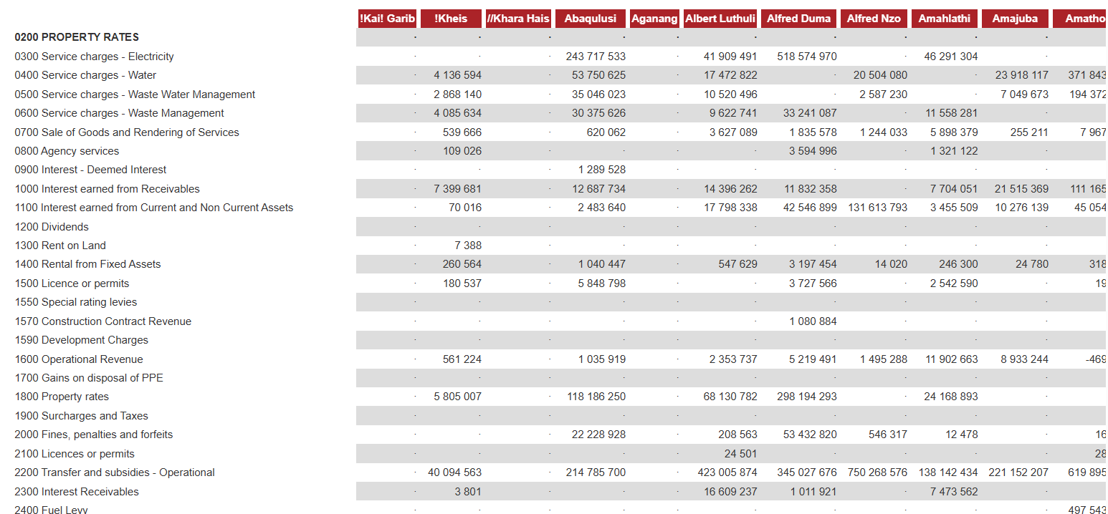
Figure 5 Raw municipal data as presented on Municipal Money website

4.3.2 Data Cleaning
Data cleaning is a step that exists to ensure data quality is enhanced and it was completed using Jupyter Notebook. In the case of this study it may be necessary due to due to situations such as administrative instability and uneven municipal record-keeping systems. Clean data ensures the machine learning process is efficient and accurate for the prediction model.

4.3.3 Filtering Out Non-Audited Records
The first cleaning task was completed immediately after loading the municipal data into Jupyter Notebook for the model. The Municipal Money datasets contain multiple types of financial figures, the data was filtered to retain only records where the “amount_type.code” was equal to “AUDA” which means Audited Actual and where “period_length.length” was equal to “year”. This omitted the inclusion of any unaudited or partial year figures that had the potential to disturb the model’s learning.

4.3.4 Removing Irrelevant Columns
The raw dataset included metadata columns that would have carried little to no value to the model training and prediction task. This included columns such as “amount_type.label”, ”amount_type.code” ,”period_length.length” and “item.composition”. Therefore only columns that are relevant to this study and the model’s training were retained. This removal of irrelevant columns reduces the dimensionality of each dataset before any merging is done.

4.3.5 Removing Item Level Duplication
In the raw downloaded dataset, each municipality appeared more than once a year with one row for each financial item. This was caused by the data being recorded at line-item level. This could have resulted in severe duplication of the dataset after merging. To avoid any duplication the data was aggregated to a municipality year level so each municipality appeared exactly once in the merged dataset.

4.3.6 Handling Missing Values Using Median Imputation
The merged dataset contained a large number of missing values, particularly in the revenue, repairs and maintenance and debt impairment variables, which were missing for between 55% and 77% of records. An earlier version of the model replaced missing values with zeros, which wrongly treated values that were not reported as zero expenditure. The final models therefore used median imputation combined with missing value indicators, implemented with the SimpleImputer function from the scikit learn library.
The missing data were handled as follows:
- Unknown labels: 509 records had no irregular, unauthorised or fruitless and wasteful expenditure data, so their outcome label could not be determined. These records were excluded rather than imputed, because treating them as low risk would have introduced a false pattern.
- Median imputation: Remaining missing values in the input features were replaced with the median of each variable. The medians were calculated from the training years only, inside the modelling pipeline, so that no information from the test years was used.
- Missing value indicators: For each variable with missing values, a binary indicator was added to record whether the value had been reported. This allows the model to learn whether non reporting is itself associated with financial governance risk.
- No variables were dropped: Several variables, such as water revenue and debt impairment, were missing for more than half of the records. They were retained with their indicators rather than removed, and this level of missing data is acknowledged as a limitation of the study.

4.3.7 Removing Data Leakage
Data leakage occurs when a model is given information during training that would not be available at the time of prediction, and it is a widespread cause of overly optimistic results in machine learning research (Kapoor & Narayanan, 2023:1). The first version of the model achieved near perfect scores, with a ROC AUC of 0,99 for the Decision Tree and 1,00 for the Random Forest. Inspection showed that irregular, unauthorised and fruitless and wasteful expenditure, the three variables used to define the target, had been included as input features. They were removed, as shown in the code below.
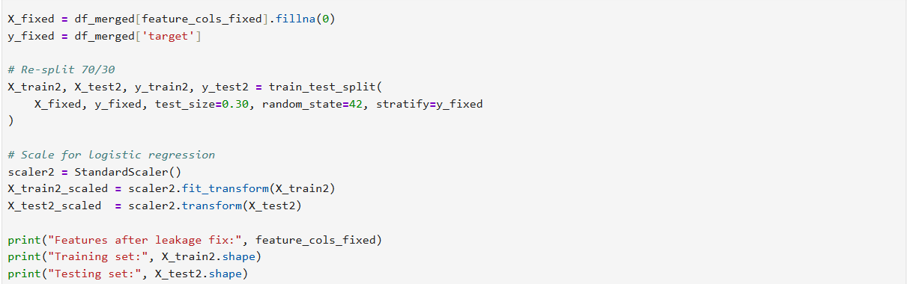
Figure 6 Code for removing data leakage
Removing these columns was not enough. The second version still used trend features calculated from the same year's irregular expenditure, included the municipality code and year as features, labelled records with missing expenditure data as low risk and split the data randomly, so the same municipality appeared in both the training and testing sets in neighbouring years. The final models address each of these problems: every feature is taken from the previous financial year, the municipality code and year are excluded, records with unknown labels are excluded and the models are always tested on years later than those used for training.

4.3.8 Filling Residual Missing Values in Engineered Features
After feature engineering was completed the yearly irregular expenditure variable included missing values for the first recorded year of each municipality. This was a result of not having a prior year to include in the calculation of change, In the final models, these values were treated in the same way as other missing values, through median imputation with a missing value indicator.

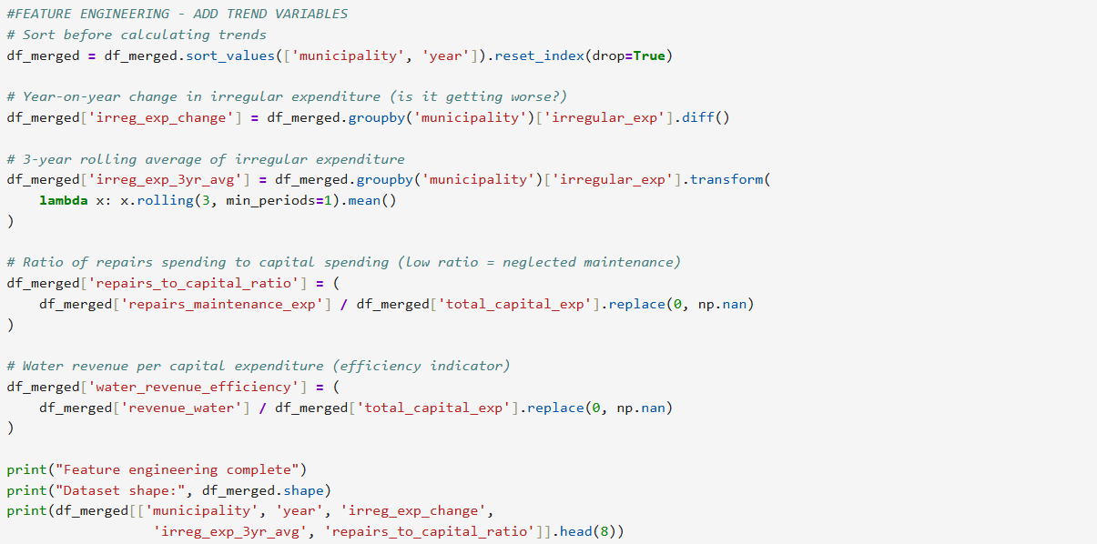
Figure 7 Code for feature engineering

4.4 Experimentation Conducted (ML Implementation)
This section describes how the data were partitioned and how the models were trained and tuned. All models were implemented in Python with the scikit learn library, in the scripts train_financial_risk.py (temporal holdout) and retrain_financial_risk_rolling.py (rolling backtest).

4.4.1 Data Partitioning
After excluding records with unknown labels and aligning each outcome year with the previous year's financial data, 2 617 municipality year records remained, covering outcome years from 2013 to 2024. Only 213 to 234 municipalities were usable in each year. Because the purpose of the model is to anticipate future risk, the data were partitioned by time rather than at random. A random split would allow the model to learn from later years and from the same municipality's neighbouring years, which would overstate its ability to predict the future. Two designs were used:
- Temporal holdout: the models were trained on outcome years 2013 to 2020 (1 765 records) and tested on 2021 to 2024 (852 records), using a fixed classification threshold of 0,5.
- Rolling backtest: each year from 2019 to 2024 was predicted by models trained only on earlier years, giving 1 278 test predictions across six years. This repeats the situation of an analyst making a fresh forecast each year.
High risk records made up 84,5% of the temporal holdout test set and 85,2% of the rolling backtest. Only 27 to 38 low risk municipalities appear in each test year, so the models have few examples of the minority class to learn from and be tested on.

4.4.2 Algorithm Training
Each algorithm was trained within the same pipeline: median imputation with missing value indicators, standardisation of every feature to a mean of 0 and a standard deviation of 1, and then the classifier. Because the imputation and scaling steps are part of the pipeline, their parameters are learned from the training years only and then applied to the test years, which prevents information from the test years leaking into training. Standardisation is required for Logistic Regression and does not affect the tree based models. A fixed random state of 42 was used throughout so that the results can be reproduced.

4.4.3 Hyperparameter Tuning and Threshold Selection
Hyperparameters were selected through grid search with expanding window validation: for each validation year, the models were fitted on all earlier training years only. In the temporal holdout the search used validation years 2017 to 2020 and selected settings by F1 score; in the rolling backtest the search selected settings by ROC AUC. In the final models fitted on all years, the selected Random Forest used balanced class weights, unlimited depth, a minimum of eight samples per leaf and the square root of the number of features at each split. The selected Decision Tree used balanced class weights, a maximum depth of three and at least 15 samples per leaf, and the selected Logistic Regression used a regularisation strength of 0,1.
Because the classes are imbalanced, the default threshold of 0,5 tends to classify almost every municipality as high risk. In the rolling backtest two thresholds were therefore chosen for each model using predictions on the training years only: a balanced threshold that maximises balanced accuracy, and a high recall threshold that gives the highest specificity while still identifying at least 95% of high risk cases.

4.5 Analysis of Results and Trustworthiness
This section presents the results of the temporal holdout and the rolling backtest, compares them with the earlier model versions, discusses trustworthiness and reports the SHAP analysis. Because most records are high risk, accuracy and F1 score can be overoptimistic on these data (Chicco & Jurman, 2020:1), and ROC curves can be visually deceptive (Saito & Rehmsmeier, 2015:1). The results are therefore read mainly through balanced accuracy, specificity and the comparison with the two baselines.

4.5.1 Temporal Holdout Results
Table 2 Temporal holdout results, test years 2021 to 2024
Model | Accuracy | Balanced accuracy | Recall (high risk) | Specificity (low risk) | F1 | ROC AUC
Majority baseline | 0,845 | 0,500 | 1,000 | 0,000 | 0,916 | n/a
Prior year persistence | 0,856 | 0,720 | 0,917 | 0,523 | 0,915 | n/a
Logistic Regression | 0,845 | 0,500 | 1,000 | 0,000 | 0,916 | 0,728
Decision Tree | 0,863 | 0,588 | 0,986 | 0,189 | 0,924 | 0,781
Random Forest | 0,863 | 0,600 | 0,981 | 0,220 | 0,923 | 0,826

At the default threshold, Logistic Regression classified every municipality as high risk, which made it identical to the majority baseline. The Random Forest and Decision Tree were 1,8 percentage points more accurate than the majority baseline, but they recognised only 22% and 19% of low risk municipalities respectively. The prior year persistence baseline achieved a much higher balanced accuracy (0,720) than any of the models. The Random Forest had the highest ROC AUC (0,826), which shows that its predicted probabilities rank municipalities by risk better than chance, but the 0,5 threshold turned these probabilities into almost blanket high risk predictions.
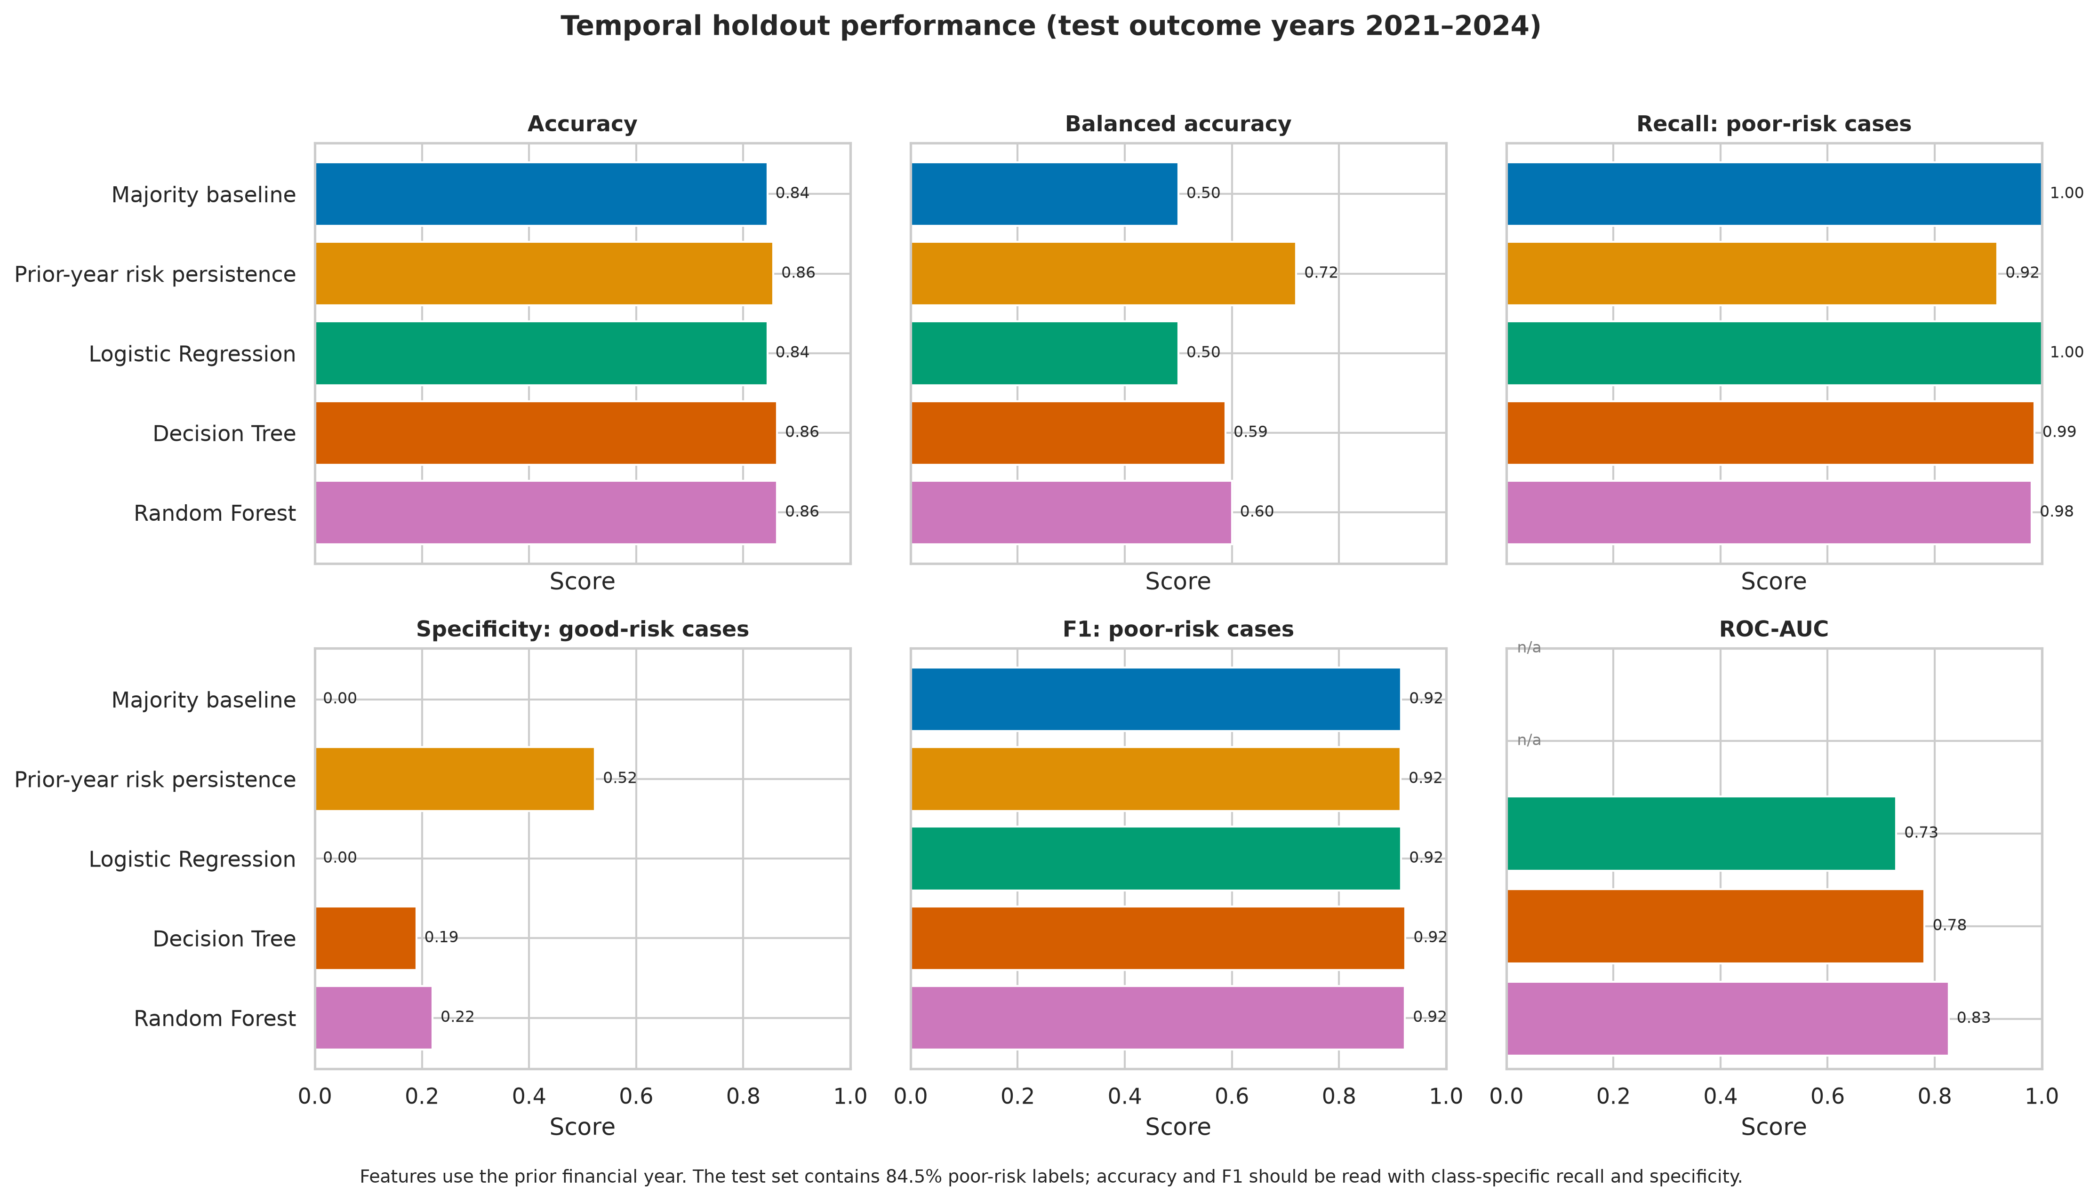
Figure 8 Temporal holdout performance of the models and baselines
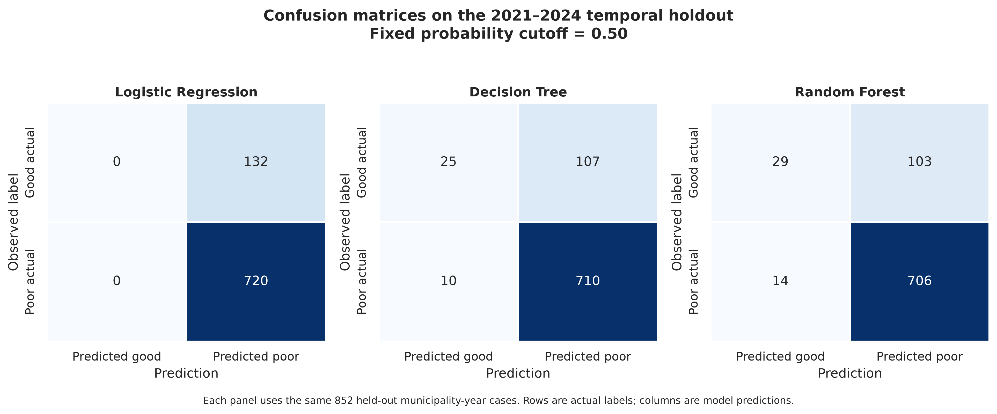
Figure 9 Confusion matrices for the temporal holdout at a threshold of 0,5
The confusion matrices show the same pattern. Of the 132 low risk cases in the test years, Logistic Regression recognised none, the Decision Tree 25 and the Random Forest 29. The ROC and precision recall curves confirm that the Random Forest ranks risk best, although the precision recall curves all start from a baseline of 0,85, the share of high risk cases, so their high values overstate the improvement.
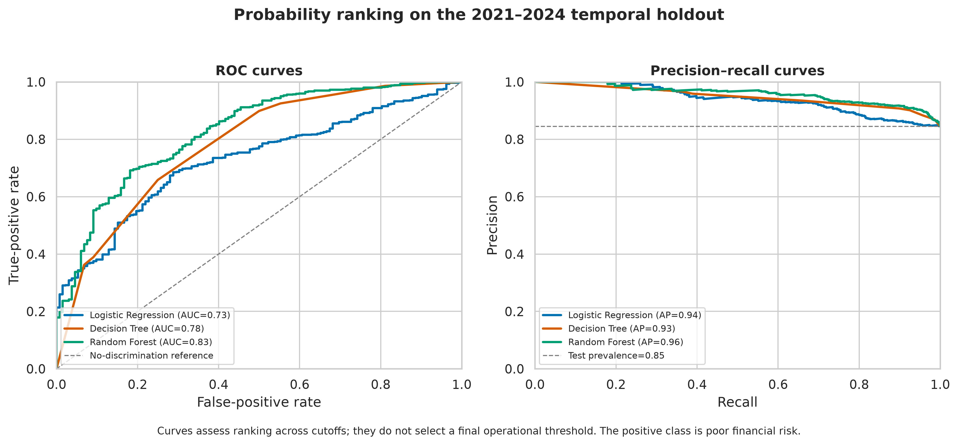
Figure 10 ROC and precision recall curves for the temporal holdout
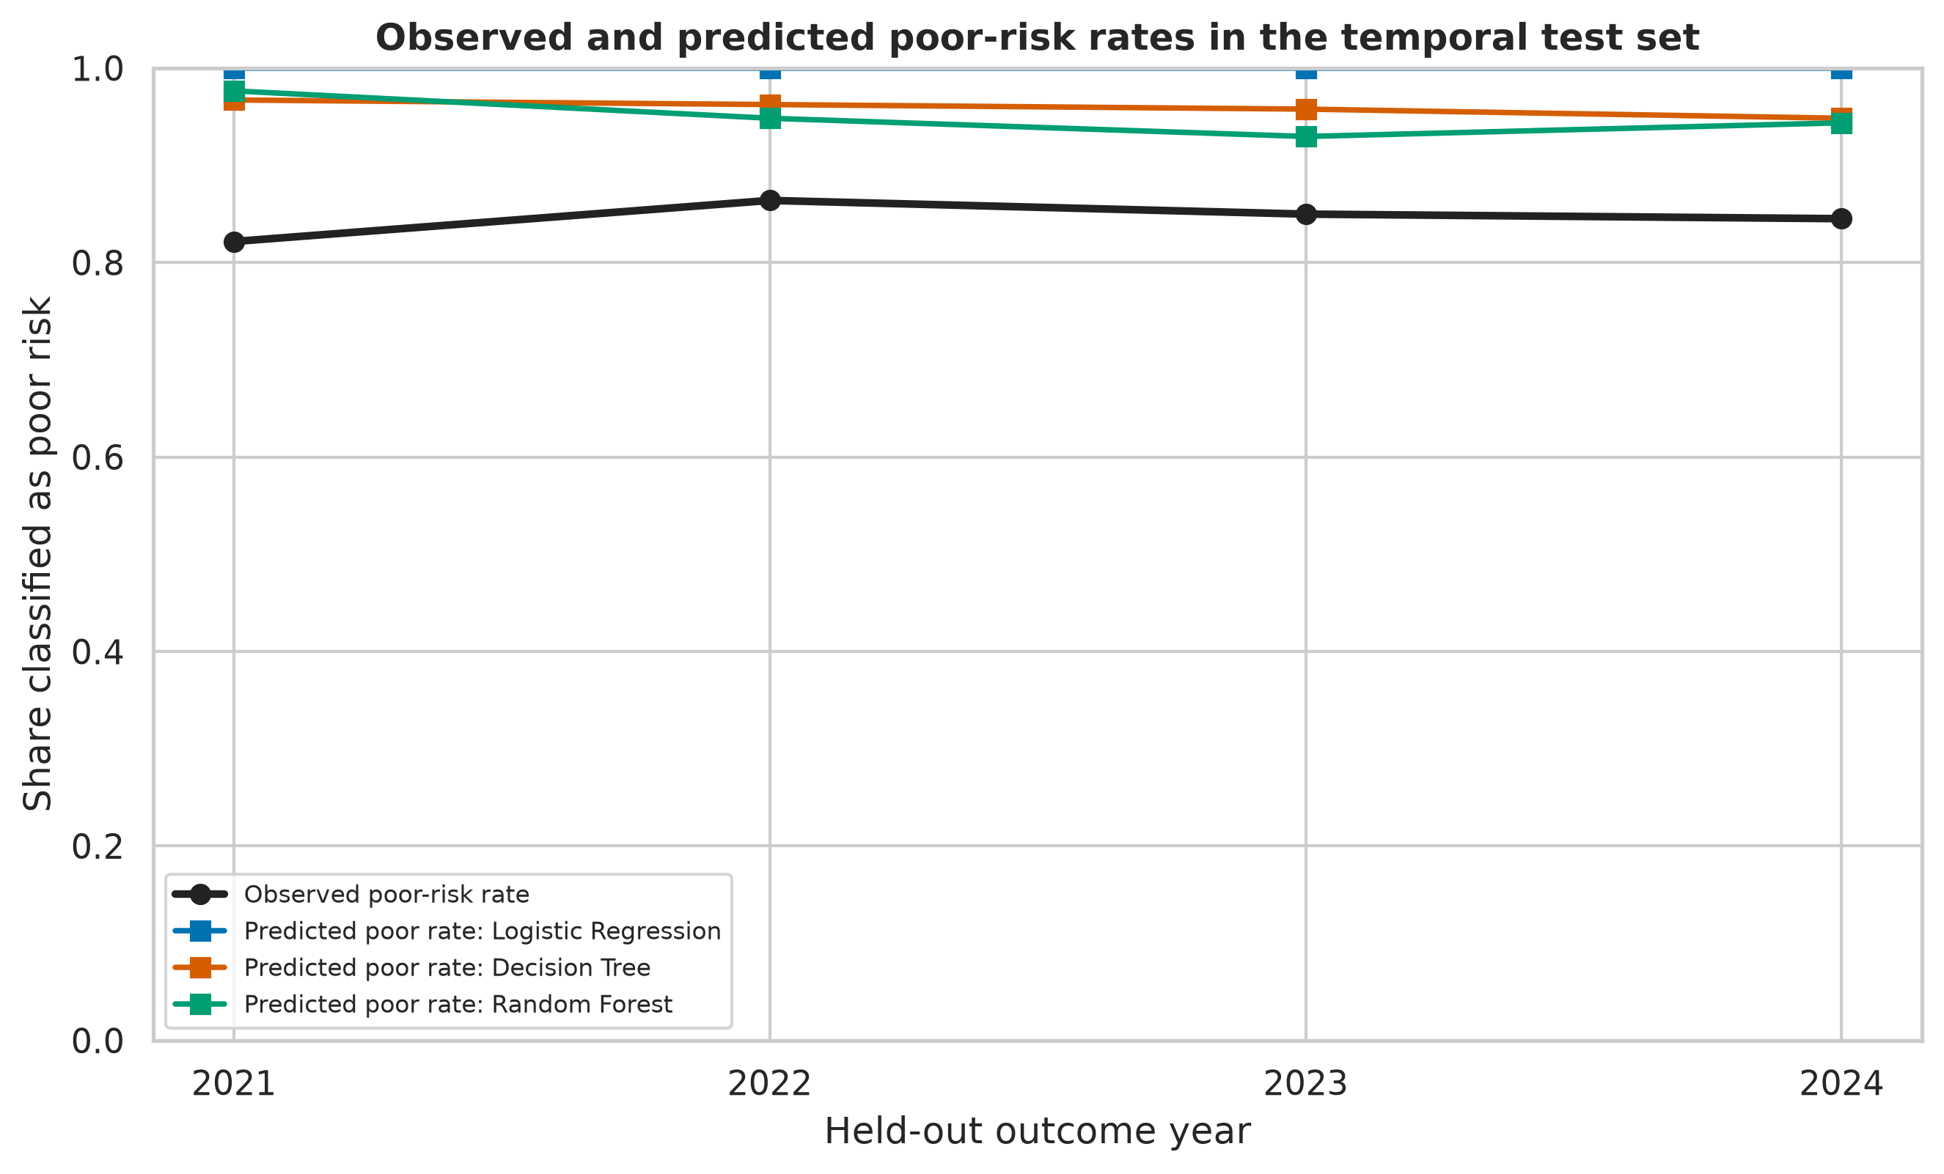
Figure 11 Observed and predicted share of high risk municipalities by test year
In every test year the models predicted more high risk municipalities than were observed. The observed share was 82% to 86%, while the Random Forest predicted 93% to 98% and Logistic Regression 100%. The models therefore over predict the majority class.

4.5.2 Rolling Backtest Results
Table 3 Rolling backtest results, test years 2019 to 2024
Model and threshold | Accuracy | Balanced accuracy | Recall (high risk) | Specificity (low risk) | ROC AUC | Missed high risk / false alarms
Majority baseline | 0,852 | 0,500 | 1,000 | 0,000 | n/a | 0 / 189
Prior year persistence | 0,850 | 0,706 | 0,910 | 0,503 | n/a | 98 / 94
Logistic Regression, balanced | 0,767 | 0,627 | 0,826 | 0,429 | 0,736 | 190 / 108
Decision Tree, balanced | 0,799 | 0,696 | 0,842 | 0,550 | 0,740 | 172 / 85
Random Forest, balanced | 0,829 | 0,718 | 0,875 | 0,561 | 0,820 | 136 / 83
Logistic Regression, high recall | 0,828 | 0,529 | 0,953 | 0,106 | 0,736 | 51 / 169
Decision Tree, high recall | 0,847 | 0,585 | 0,958 | 0,212 | 0,740 | 46 / 149
Random Forest, high recall | 0,868 | 0,634 | 0,966 | 0,302 | 0,820 | 37 / 132

With the balanced threshold, the Random Forest was the best of the three algorithms, with a balanced accuracy of 0,718 and a ROC AUC of 0,820. It identified 87,5% of high risk cases and 56,1% of low risk cases. However, its balanced accuracy was only about one percentage point higher than that of the prior year persistence baseline (0,706), and its overall accuracy (82,9%) was below that of the majority baseline (85,2%). With the high recall threshold, the Random Forest identified 96,6% of high risk cases, but it also classified 132 of the 189 low risk cases as high risk.
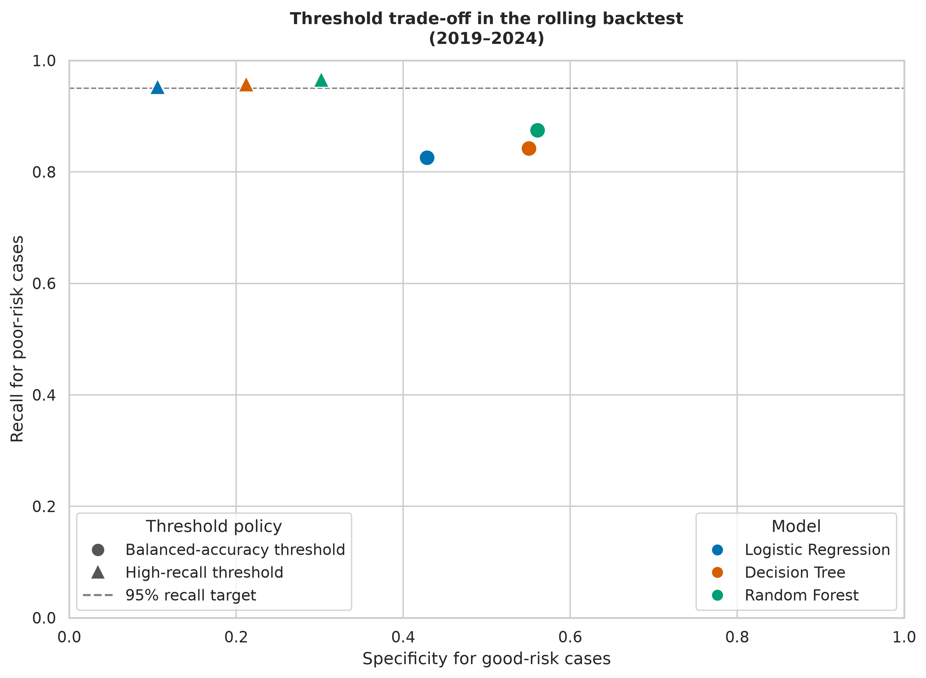
Figure 12 Trade off between recall for high risk cases and specificity for low risk cases in the rolling backtest
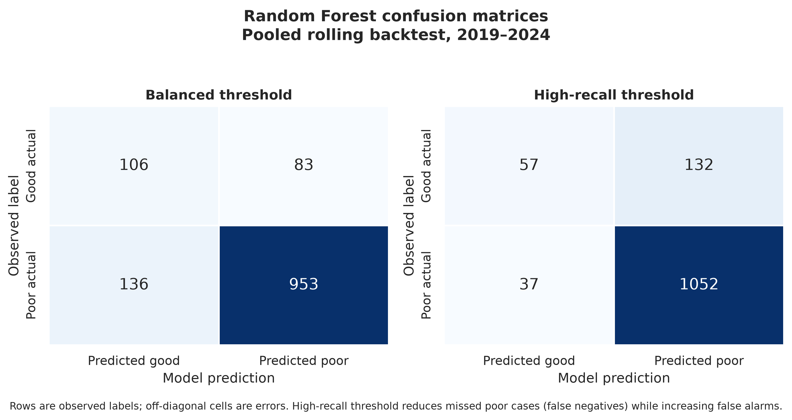
Figure 13 Random Forest confusion matrices for the rolling backtest, pooled over 2019 to 2024
No model achieves both high recall and high specificity: improving one comes at the cost of the other. Performance also varied considerably between years. With the balanced threshold, the Random Forest's specificity ranged from 0,33 in 2020 to 0,69 in 2022, and with the high recall threshold it fell to zero in 2020, when every municipality was classified as high risk. This instability is consistent with the small number of low risk cases in each year.
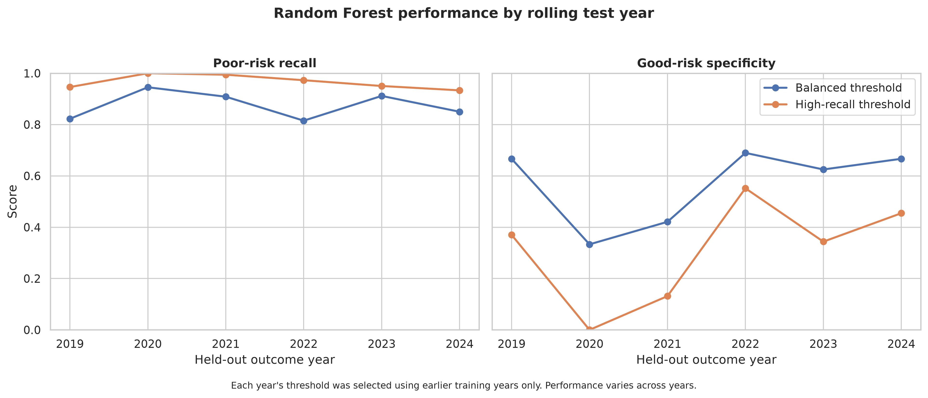
Figure 14 Random Forest recall and specificity by rolling test year

4.5.3 Comparison with Earlier Model Versions
The earlier versions of the model produced much higher scores because of the leakage described in Section 4.3.7. As the leakage was removed and the evaluation became more realistic, accuracy fell from 0,994 to between 0,829 and 0,868, and ROC AUC fell from 1,000 to about 0,82. The earlier versions also did not report balanced accuracy or specificity, which would have revealed how poorly low risk municipalities were recognised. The results of the earlier versions are reported only to document the development of the model and are not valid estimates of predictive performance.
Table 4 Random Forest performance across development rounds
Development round | Evaluation design | Random Forest accuracy | Balanced accuracy | ROC AUC
First version (target leakage) | Random split, same year features | 0,994 | not measured | 1,000
Second version (residual leakage) | Random split, same year trend features | 0,872 | not measured | 0,942
Temporal holdout | Train 2013 to 2020, test 2021 to 2024 | 0,863 | 0,600 | 0,826
Rolling backtest, balanced threshold | Each year 2019 to 2024 from earlier years | 0,829 | 0,718 | 0,820
Rolling backtest, high recall threshold | Each year 2019 to 2024 from earlier years | 0,868 | 0,634 | 0,820

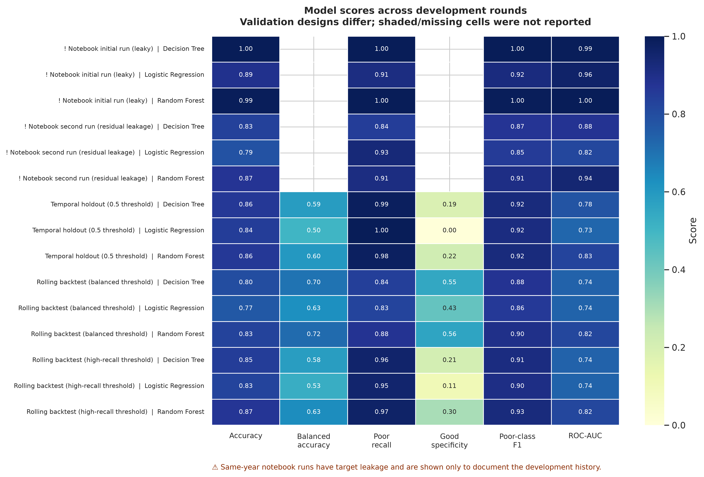
Figure 15 Model scores across all development rounds

4.5.4 Trustworthiness
Internal validity was strengthened by removing every identified source of leakage: features are taken only from the previous year, the municipality code and year are excluded, records with unknown labels are excluded, and imputation, scaling, tuning and threshold selection use the training years only. Reliability is supported by the fixed random state of 42 and by scripts that reproduce every result from the same data.
External validity is limited. Only 213 to 234 of the 292 municipalities could be used in each year, several financial variables were missing for more than half of the records, and the target is a financial governance proxy rather than a direct measure of water service delivery. In addition, the 2019 to 2024 backtest years were examined while the models were being developed, so they should be regarded as development evidence rather than an untouched final test. A newly labelled year, such as 2025, would provide a genuinely independent test.
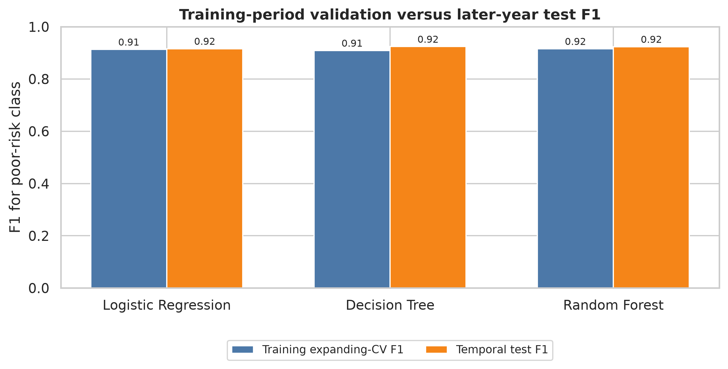
Figure 16 F1 score during training validation compared with the temporal holdout test
The F1 scores during validation (about 0,91) and testing (about 0,92) were consistent. This consistency does not show that the models are accurate, however, because the majority baseline also achieves an F1 score of 0,916 on these data.

4.5.5 SHAP Interpretability
SHAP values were calculated for the final Random Forest, fitted on all 2 617 records, to identify which previous year variables contribute most to its predictions. The four most important variables were the previous year's unauthorised expenditure, the three year average of irregular expenditure, irregular expenditure and fruitless and wasteful expenditure, followed by the change in irregular expenditure. These are the same expenditure categories that define the target. Operational variables such as contracted services, capital expenditure, employee costs, water revenue and repairs and maintenance contributed far less, and the indicators for unreported values played only a minor role.
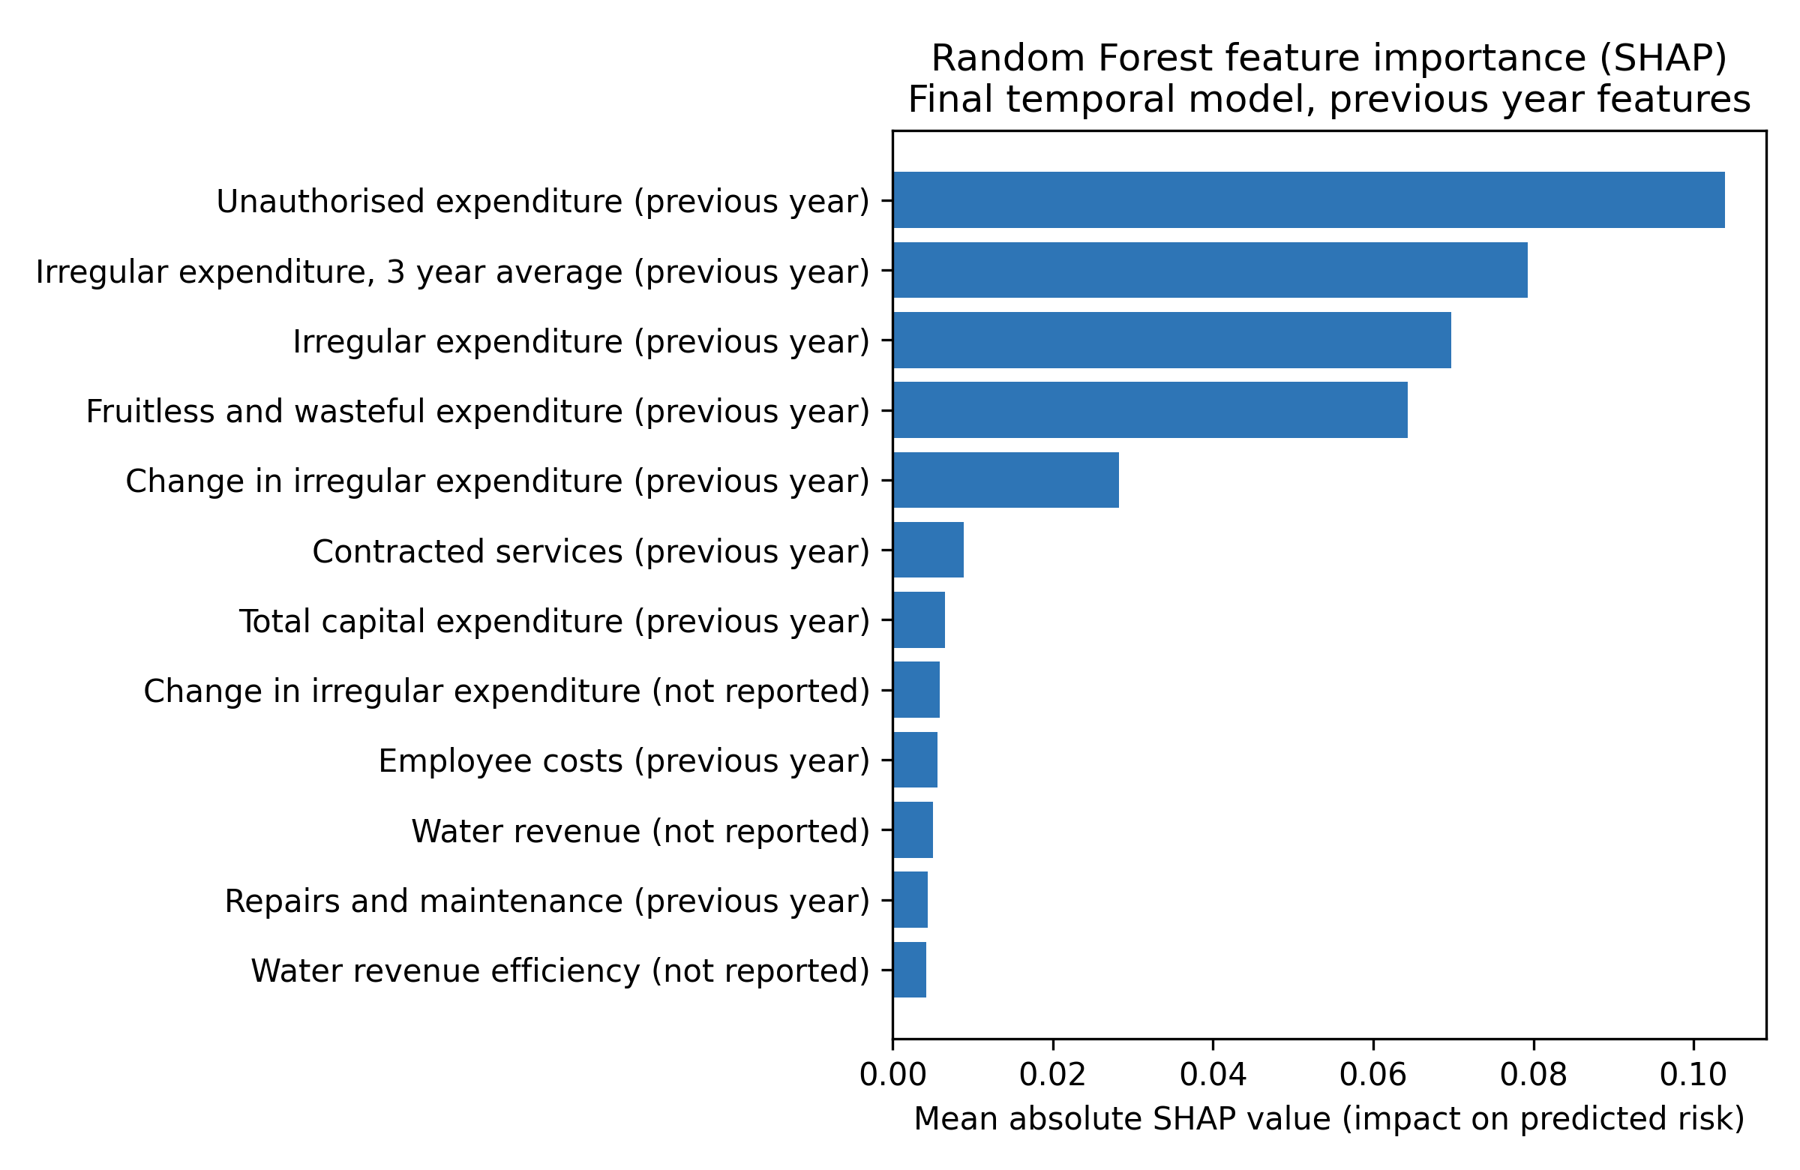
Figure 17 Mean absolute SHAP values for the final Random Forest
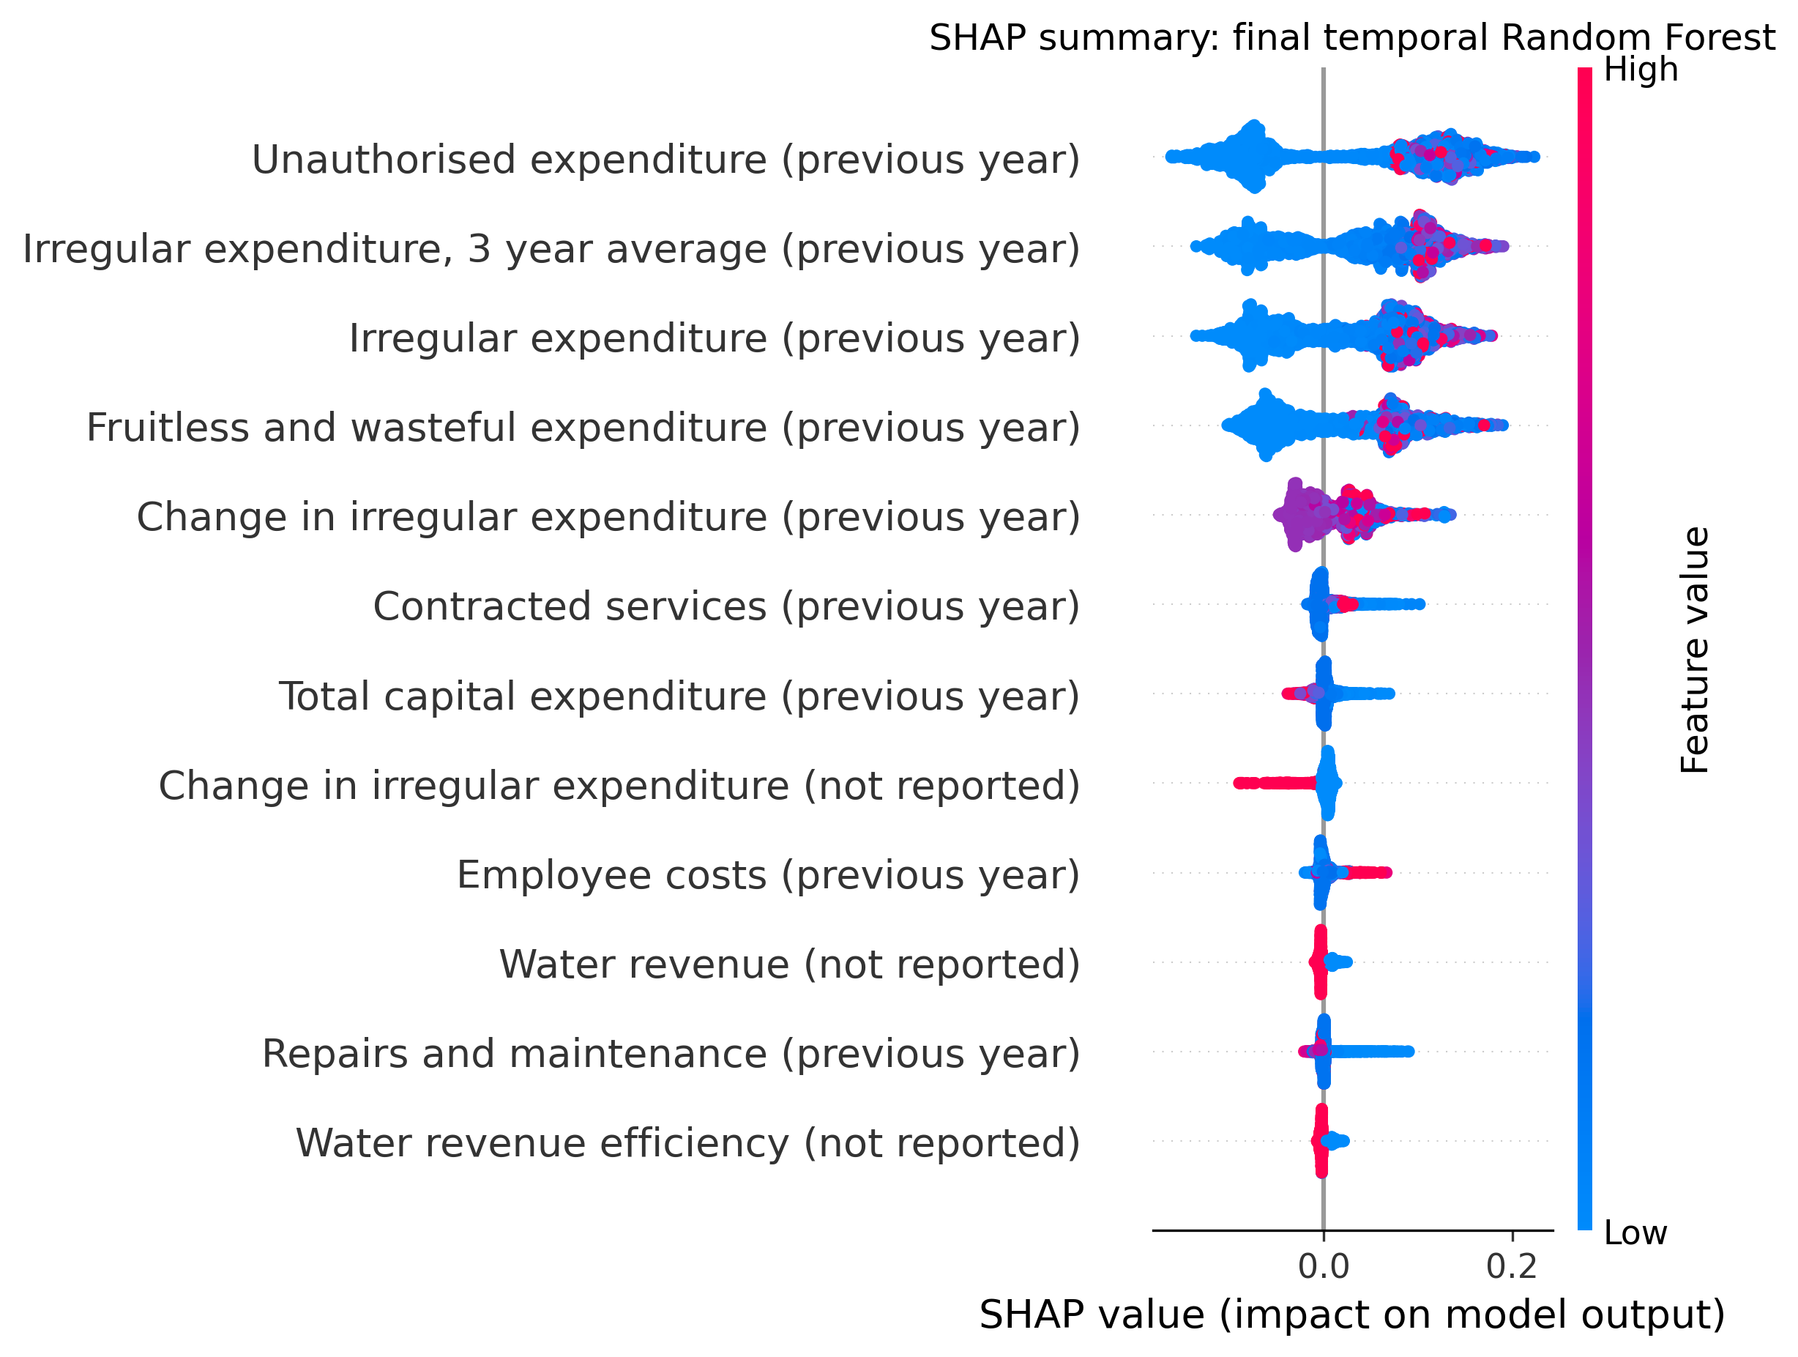
Figure 18 SHAP summary plot for the final Random Forest
The SHAP results show that the model mainly learns that financial governance risk persists from one year to the next: a municipality with high irregular or unauthorised expenditure in one year is likely to exceed the thresholds again in the following year. This explains why the prior year persistence baseline performs almost as well as the Random Forest. The weak contribution of water related variables may partly reflect how often they are missing.

4.6 Findings
Three supervised machine learning algorithms were evaluated to determine how well publicly available municipal financial data can predict next year financial governance risk, as a proxy early warning indicator for water service delivery risk. This section summarises the findings on model performance, risk factors and the limitations of the data.

4.6.1 Model Performance
The Random Forest performed best of the three algorithms. It had the highest ROC AUC in both designs (0,826 and 0,820) and the highest balanced accuracy in the rolling backtest (0,718). Its predicted probabilities therefore carry a real but moderate signal about future financial governance risk. Its classification performance, however, was modest: it was only slightly better than repeating the previous year's label, its accuracy was below that of classifying every municipality as high risk and it recognised only about half of the low risk municipalities. On this evidence, the models cannot be claimed to predict financial governance risk, or water service delivery outcomes, accurately. They are better described as an exploratory screening approach.

4.6.2 Risk Factors
The strongest predictors of high financial governance risk were the previous year's levels of unauthorised, irregular and fruitless and wasteful expenditure and the trend in irregular expenditure over several years. This is consistent with the literature, which identifies irregular expenditure as a persistent problem behind the decline in clean audit outcomes (S Mnguni, 2022:157). Variables more directly connected to water services, such as water revenue and repairs and maintenance, contributed little, so the study could not identify operational warning signs of water service failure from these data.

4.6.3 Limitations of the Data
The results are constrained by the data. After excluding unknown labels, only 2 617 records were usable, with 213 to 234 municipalities per year and only 27 to 38 low risk cases in each test year. Water revenue, debt impairment and repairs and maintenance were missing for between 64% and 77% of records. No direct water service outcome data could be linked to the label, so the relationship between financial governance risk and water service delivery remains untested.

4.7 Conclusion
This chapter developed and evaluated three supervised machine learning models that use the previous year's public municipal financial data to predict next year financial governance risk. Once leakage was removed and the models were tested on later years, the Random Forest performed best, with a ROC AUC of 0,82 and a balanced accuracy of 0,72 in the rolling backtest. This performance is only slightly better than simply repeating the previous year's label, and the high scores of the earlier model versions were shown to result from data leakage.
The study therefore does not support a claim that machine learning can accurately predict water service delivery outcomes from these data. It does show that public financial records contain some early warning signal about future financial governance risk, that this risk is highly persistent and that careful, leakage free evaluation is essential before predictive models are used to inform municipal oversight. Chapter 5 reflects on these findings in relation to the research questions and objectives and sets out recommendations for future research.

CHAPTER 5: CONCLUSION

5.1 Introduction
This chapter discusses the conclusion of the research study with title Predicting Municipal Financial Governance Risk as an Early Warning Indicator for Water Service Delivery: A Machine Learning Approach. The South African local government is defined as the primary sphere for ensuring the constitutional law specified in Section 27(1)(b) of the Constitution of the Republic of South Africa is obliged to. This law states that Water Service Authorities are responsible for providing safe and good quality water supply to communities on a continuous basis (Ishola et al., 2025:76; Seema et al., 2025:1). To promote transparency and accountability in governance the local government relies on reporting frameworks (S Mnguni, 2022:148).

Even with the existence of the reporting frameworks, the local government’s service delivery in water supply is declining. Many communities are marked by persistent water supply interruptions, old infrastructure, high amounts in non-revenue water losses and an increase in public protesting against municipalities (Mamokhere, 2025:31). The main challenge that contributes to the poor water service delivery outcomes in governance was identified to being the results from the compliance gap that exists in governance administration. This suggests that reporting frameworks such as Auditor-General South Africa (AGSA) publish audit results that do not necessarily reflect the actual water service delivery being received by many communities (Khasodi et al., 2023:338). Therefore, municipalities may achieve consecutive positive results on audit reports while the communities they are responsible for suffer in the background.

This study responded to this gap by implementing, comparing and evaluating three supervised machine learning algorithms. Because public sources do not provide structured water service data, such as interruption records, for every municipality and year, the models predicted next year municipal financial governance risk from the previous year’s financial data, including repairs and maintenance expenditure, water service revenue and capital investment. This risk was treated as a proxy early warning indicator for water service delivery, and linking the predictions to direct water service measures is recommended for future studies.

The remainder of this chapter discusses the overview of the research journey and the achievement of objectives where the research questions and objectives will be covered in Section 5.2. Followed by the discussion of the study’s academic, governance and methodological contributions in Section 5.3, with the limitations identified and recommendations for future studies in Section 5.4. Then Section 5.5 discusses the study’s trustworthiness with Section 5.6 and 5.7 concluding the study’s remarks.

5.2 Overview of Research Journey and Achievement of Objectives
This section discusses how the study followed the Positivism approach using quantitative methods and also evaluates whether all research questions were answered and objectives achieved.

5.2.1 Evaluation of Research Questions
- Main RQ: This research question was partly answered. When trained on earlier years and tested on later years, the Random Forest ranked municipalities by next year financial governance risk better than chance (ROC AUC 0,82 in the rolling backtest), but its classification performance was only slightly better than repeating the previous year’s label, and its accuracy was below that of classifying every municipality as high risk. Public financial data therefore contain some early warning signal, but the models cannot be claimed to predict financial governance risk, or water service delivery outcomes, accurately.
- TRQ1: This research question was answered in Chapter 3 (Sections 3.2.1 and 3.3.1), which reviewed the constitutional and legislative mandate for water services, the uneven state of access, ageing infrastructure, governance weaknesses and the protests that follow service failure.
- TRQ2: This research question was answered in Chapter 3 (Sections 3.2.2 and 3.3.2), which showed that audit outcomes measure administrative compliance rather than service performance, and that even the Midvaal Local Municipality's consecutive clean audits cannot on their own be used as a determinant of good service delivery (Khasodi et al., 2023:347).
- RQ1: This research question was answered in Chapter 4 through data collection from the National Treasury Municipal Money repository. Records whose outcome label could not be determined were excluded, and the remaining missing values were handled through median imputation with missing value indicators, calculated from training data only. This retained incomplete records without treating unreported values as zero.
- RQ2: This research question was answered in Chapter 4 (Section 4.5). The Random Forest performed best of the three algorithms, with the highest ROC AUC in both the temporal holdout (0,826) and the rolling backtest (0,820) and the highest balanced accuracy in the rolling backtest (0,718), followed by the Decision Tree and Logistic Regression. However, its balanced accuracy was only about one percentage point higher than that of the prior year persistence baseline (0,706), and at the default threshold Logistic Regression classified every municipality as high risk.
- RQ3: This research question was answered by applying SHAP analysis to the final Random Forest. The strongest predictors were the previous year’s unauthorised, irregular and fruitless and wasteful expenditure and the trend in irregular expenditure, while water related variables such as water revenue and repairs and maintenance contributed little (Chapter 4, Sections 4.5.5 and 4.6.2). This shows that financial governance risk is highly persistent from one year to the next.
- RQ4: This research question was partially answered. The model’s probability rankings could help oversight bodies prioritise municipalities for closer review before annual audit results are published, but its modest accuracy means that its outputs should be treated as screening information to be combined with other evidence, not as definitive assessments.

5.2.2 Research Objectives
Objective | Status | Evidence of Achievement in Report
T-OBJ1 | Achieved | Chapter 3 (Sections 3.2.1 and 3.3.1) reviewed the Section 27(1)(b) constitutional mandate, Water Services Act obligations, ageing asbestos pipe infrastructure in Modimolle Mookgophong, load shedding impacts and service delivery protest trends.
T-OBJ2 | Achieved | Chapter 3 (Sections 3.2.2 and 3.3.2) critically synthesised empirical literature showing that AGSA clean audits measure financial reporting regularity rather than physical service delivery, including the Midvaal Local Municipality case study and Western Cape audit outcomes.
E-OBJ1 | Achieved | Chapter 4 (Section 4.3) documented the collection of municipal records from the National Treasury Municipal Money repository, the exclusion of unknown labels and the handling of missing values through median imputation with missing value indicators.
E-OBJ2 | Achieved | Chapter 4 (Section 4.4) detailed the temporal holdout and rolling backtest designs, grid search with year ordered validation and the selection of classification thresholds.
E-OBJ3 | Achieved | Chapter 4 (Section 4.5) compared the three algorithms with each other and with two baselines, establishing Random Forest as the best of the three (ROC AUC 0,820 and balanced accuracy 0,718 in the rolling backtest) while showing that its advantage over the persistence baseline was small.
E-OBJ4 | Partly achieved | Chapter 4 (Sections 4.5.5 and 4.6.2) applied SHAP to the final Random Forest, ranking the previous year’s unauthorised, irregular and fruitless and wasteful expenditure as the strongest predictors. The contribution of these insights to decision making was discussed but not tested with decision makers.

5.3 Research Contributions
By combining predictive machine learning with public sector governance literature in Sub Saharan Africa, the study addresses an interdisciplinary research gap. Its findings are consistent with the compliance performance gap described by Craig (2017), S Mnguni (2022) and Sambo (2019): financial governance indicators carry some early warning signal, but on their own they are a limited basis for judging service delivery.

The study established a replicable data collection and preprocessing procedure that integrates a standardised public sector database into a unified tabular feature matrix. It also shows how incomplete municipal administrative records can be handled through median imputation with missing value indicators, which retains sparse records while preserving the information that a value was not reported. Most importantly, it demonstrates how data leakage can inflate the apparent performance of municipal prediction models and shows that temporal validation, simple baselines and class specific measures such as specificity are needed before such models are used in practice (Kapoor & Narayanan, 2023:1). Pairing the Random Forest with SHAP analysis also made its predictions interpretable.

For practice, the study suggests that a municipality’s recent history of irregular, unauthorised and fruitless and wasteful expenditure is the clearest available warning sign of continued financial governance risk, and that oversight bodies could use such indicators to prioritise municipalities for closer attention.

5.4 Study Limitations
The predictive model pipeline relied on annual published administrative datasets. Consequently, the model’s outputs operate on an annual reporting cadence rather than providing real-time, daily operational monitoring.

Boundary realignments, municipal mergers and Category B local municipality shifts occurring across the 2012 to 2025 period required manual dataset reconciliation, which created minor record alignment complexities.
Several financial variables, including water revenue, repairs and maintenance and debt impairment, were missing for between 55% and 77% of records. These variables were retained using median imputation with missing value indicators, but this level of missing data limits what the models can learn.
The target variable is a financial governance proxy defined through expenditure thresholds. It was not validated against direct water service measures such as interruption records, household access or Blue Drop scores, so the relationship between the predicted risk and water service delivery remains untested.
Only 213 to 234 of the 292 municipalities could be used in each year, with 27 to 38 low risk cases per test year, which limits the models’ ability to recognise low risk municipalities and makes performance vary between years. The 2019 to 2024 backtest years were also examined during model development, so a newly labelled year is needed for a fully independent test.

Future research should explore hybrid frameworks that combine annual institutional financial indicators with real-time Internet of Things (IoT) water flow, pressure and quality telemetry. Also, expanding the algorithmic baseline to include Deep Neural Networks (DNNs), Convolutional Neural Networks (CNNs) for satellite-based infrastructure monitoring and Spatial Econometric ML models. Future studies should also link financial governance risk to direct water service outcomes, such as Blue Drop scores and interruption records, and test the models on newly published financial years.

5.4 Conclusion
This study showed that supervised machine learning, and the Random Forest in particular, can extract some early warning signal about next year municipal financial governance risk from publicly available financial data, but that its predictive performance is modest and only slightly better than simple baselines. The study therefore does not support a claim that machine learning can accurately predict water service delivery outcomes from these data.

The research engaged directly with the compliance performance gap. Its findings suggest that financial governance indicators persist from year to year and contain useful but limited information, which supports the literature’s view that audit and financial compliance measures alone do not reliably reflect water service delivery. By demonstrating how leakage free, time ordered evaluation changes the apparent performance of a model, the study provides a realistic foundation on which future work, using richer water service data, can build more useful early warning tools for public sector decision makers, municipal managers and the Department of Water and Sanitation (DWS).

References
Abujaber, A.A., Albalkhi, I., Imam, Y., Yaseen, S., Nashwan, A.J., Akhtar, N. & Alkhawaldeh, I.M. 2025. Machine learning-based prediction of 90-day prognosis and in-hospital mortality in hemorrhagic stroke patients. Scientific Reports, 15, 16242. 10.1038/s41598-025-90944-x
Breiman, L. 2001. Random forests. Machine Learning, 45(1):5–32. https://doi.org/10.1023/A:1010933404324
Chicco, D. & Jurman, G. 2020. The advantages of the Matthews correlation coefficient (MCC) over F1 score and accuracy in binary classification evaluation. BMC Genomics, 21:6. https://doi.org/10.1186/s12864-019-6413-7
Craig, S.E. 2017. An Exploration of the Relationship between Municipal Audit Outcomes and Levels of Service Delivery in South African Local Government. UNIVERSITY OF CAPE TOWN: UNIVERSITY OF CAPE TOWN. (Master Minor Thesis).
Goede, R. Research: From Paradigm to Practice. School of Computer Science and Information Systems, North-West University.
Hirko, D.B., Du Plessis, J.A. & Bosman, A. 2026. Optimising water allocation with hybrid machine learning–water evaluation and planning under climate and population pressure in Upper Awash–Akaki, Ethiopia. Journal of Hydroinformatics, 28(1):14–37. 10.2166/hydro.2026.098
Igbokwe, N.C. & Nwamekwe, C.O. 2025. Application of Machine Learning in Predicting Emergency Obstetric Cases in Sub-Saharan Africa: An Early Appraisal. International Journal of Industrial Engineering, Technology & Operations 3(1):13–22. 10.62157/ijietom.v3i1.78
Ishola, A.A., Maramura, T.C. & Gumbo, T. 2025. Analysing Metropolitan Municipal Water Services Delivery Performance in South Africa: A Comparative Assessment of Household Access, Water Quality, and Households’ Satisfaction. Journal of Digital Food, Energy & Water Systems [JD-FEWS], 6(1):75–95.
Kapoor, S. & Narayanan, A. 2023. Leakage and the reproducibility crisis in machine-learning-based science. Patterns, 4(9):100804. https://doi.org/10.1016/j.patter.2023.100804
Khasodi, M.S., Mahlala, S. & Hofisi, C. 2023. Assessment of clean audit outcomes as an effective determinant of good service delivery: a case study of Midvaal Local Municipality. International Journal of Research in Business and Social Science (IJRBS), 12(9):338–350. https://doi.org/10.20525/ijrbs.v12i9.3012
Lundberg, S.M. & Lee, S.-I. 2017. A unified approach to interpreting model predictions. (In Advances in Neural Information Processing Systems 30 (NIPS 2017). p. 4765–4774).
Mamokhere, J. 2025. Service delivery conundrums in South African municipalities. Insights Into Regional Development, 7(2):30–42. https://jssidoi.org/ird/ https://doi.org/10.70132/b5776454636
Mofokeng, S., Ramolobe, K.S. & Bogopa, D.L. 2025. Assessing the impact of digital technologies on service delivery in local government. Journal of Local Government Research and Innovation, 6(0):a234. a234. https://doi.org/10.4102/jolgri.v6i0.234
Ngcobo, M. 2025. The ethics and law of medical AI in South Africa: Balancing innovation with responsibility. South African Medical Journal (SAMJ), 115(5b):75–79. e3667. https://doi.org/10.7196/SAMJ.2025.v115i5b.3667
Ngcobo, S., Mntla, E.M., Shock, J., Louw, M., Mbonambi, L., Serite, T. & Rossouw, T. 2025. Artificial intelligence for HIV care: a global systematic review of current studies and emerging trends. Journal of the International AIDS Society, 10.1002/jia2.70045
Nodipha, C., Konyana, S., Asoba, S.N. & Mefi, N.P. 2025. The Downside of Water Service Delivery in the Mnquma Local Municipality, South Africa. Journal of Ecohumanism, 4(4):1371–1378. https://doi.org/10.62754/joe.v4i4.6870
Obunga, P.O., Rwanga, S.S., Dinka, M.O. & Otieno, B.O. 2025. Review of the emerging technologies in the water sector with a focus on the deployment of Internet of Things solutions. npj Clean Water (Published in partnership with King Fahd University of Petroleum & Minerals):1–17. 10.1038/s41545-025-00487-x
Phumlani, D., Nkabinde, B. & Nkgapele, S.M. 2025. The usability of performance management systems as a tool in effective service delivery of the South African local government. International Journal of Research in Business and Social Science (IJRBS), 14(8):116–126. https://doi.org/10.20525/ijrbs.v14i8.4532
S Mnguni, M.S. 2022. Audit Outcome Challenges in Local Government: The Case of Three Metropolitan Municipalities in South Africa. African Journal of Public Affairs, 13(1):29.
Saito, T. & Rehmsmeier, M. 2015. The precision-recall plot is more informative than the ROC plot when evaluating binary classifiers on imbalanced datasets. PLoS ONE, 10(3):e0118432. https://doi.org/10.1371/journal.pone.0118432
Sambo, V. 2019. An Analysis of Audit Outcomes and Service Delivery at the Local Government Sphere in South Africa. Paper presented at the The 4th Annual International Conference on Public Administration and Development Alternatives, Southern Sun Hotel, OR Tambo International Airport, Johannesburg, South Africa, 3 July 2019.
Seema, T.C., Molepo, J.N. & Maleka, C.M. 2025. Water service delivery challenges in Modimolle-Mookgophong Local Municipality, Limpopo, South Africa. Journal of Local Government Research and Innovation, 6(0):1–11. a217. https://doi.org/10.4102/jolgri.v6i0.217
Sylvain, M.H., Nyabyenda, E.C., Melissa, U., Isaac, K., Fauste, N. & Innocent, N. 2025. Prediction of adverse pregnancy outcomes using machine learning techniques: evidence from analysis of electronic medical records data in Rwanda. BMC Medical Informatics and Decision Making, 25:1–13. 76. 10.1186/s12911-025-02921-z
Taweesan, A., Kanabkaew, T., Surinkul, N. & Polprasert, C. 2025. Integrating clustering algorithms and machine learning to optimize regional snapshot municipal solid waste management for achieving sustainable development goals. Environmental Advances, 19:1–8. 100607. https://doi.org/10.1016/j.envadv.2024.100607
Troyanskaya, O., Cantor, M., Sherlock, G., Brown, P., Hastie, T., Tibshirani, R., Botstein, D. & Altman, R.B. 2001. Missing value estimation methods for DNA microarrays. Bioinformatics, 17(6):520–525. https://doi.org/10.1093/bioinformatics/17.6.520

Appendix A
Code, tools, etc

Appendix B
Ethics something something

